HCMUS - VNUHCM / FIT / Computer Vision & Cognitive Cybernetics Department

Digital image & video processing - LQN

**Student ID:** 21127690

**Student name:** Ngo Nguyen Thanh Thanh

**Report: YOLO AND DARKNET**

**I. Evaluation summary:**

|  |  |  |  |
| --- | --- | --- | --- |
| **Task** | **Details of Implementation** | **Completion Percentage (%)** | **Notes** |
| **YOLOV7** | Experiment with the different dataset | 100% | Chesspieces (640x640) – 82 images |
| Set up Working directory | 100% |  |
| Download YOLOv7- Source Code | 100% |  |
| Prepare the Chess Pieces Dataset | 100% |  |
| Download pre-trained weights | 100% |  |
| Demo | 100% |  |
| Training | 100% |  |
| Test | 100% |  |
| **YOLOV11** | Expeiment with different model, different source code | 100% | Yolov11 |
| Experiment with the same dataset above | 100% | Chesspieces (640x640) – 82 images |
| Install Yolov11 via Ultralytics | 100% |  |
| Demo with CLI | 100% |  |
| Fine-tune YOLOv11 with custom dataset: Chess Pieces Dataset 640x640 | 100% |  |
| Training | 100% |  |
| Test | 100% |  |

**II. Dataset: Chess pieces Dataset 640x640**

**Link:** [https://universe.roboflow.com/junior-zyvtn/chess-pieces-d0yt3/dataset/12](https://www.google.com/url?q=https%3A%2F%2Funiverse.roboflow.com%2Fjunior-zyvtn%2Fchess-pieces-d0yt3%2Fdataset%2F12)

**Total images: 82** :0 missing annotations, 0 null examples

**Number Classes:** 12 classes

1. black-bishop
2. black-king
3. black-knight
4. black-pawn
5. black-queen
6. black-rook
7. white-bishop
8. white-king
9. white-knight
10. white-pawn
11. white-queen
12. white-rook

**Data split:**

* **Train set:** 56
* **Valid set:** 18
* **Test set:** 8

**Preprocessing:** Auto Orient: Applied

**Augumentation:** No augumentations were applied

**Number of Annotations:** 1202 (average: 14.7 per image. Across 12classes)

**Average image size:** 12.19 mp (from 12.19mp to 12.19mp)

**Median Image Ratio:** 3024x4032 (tall)

**Class Balance:** Overview of the number of annotations for each class in your dataset. (image below)

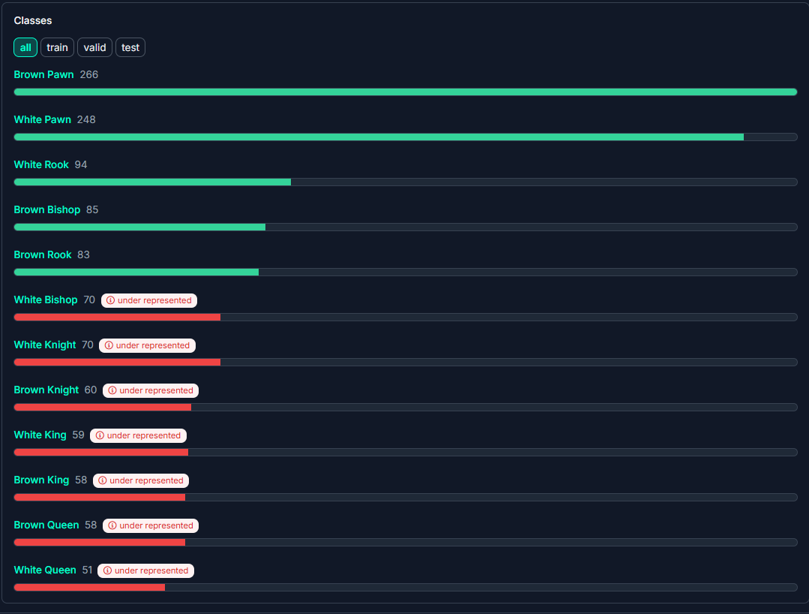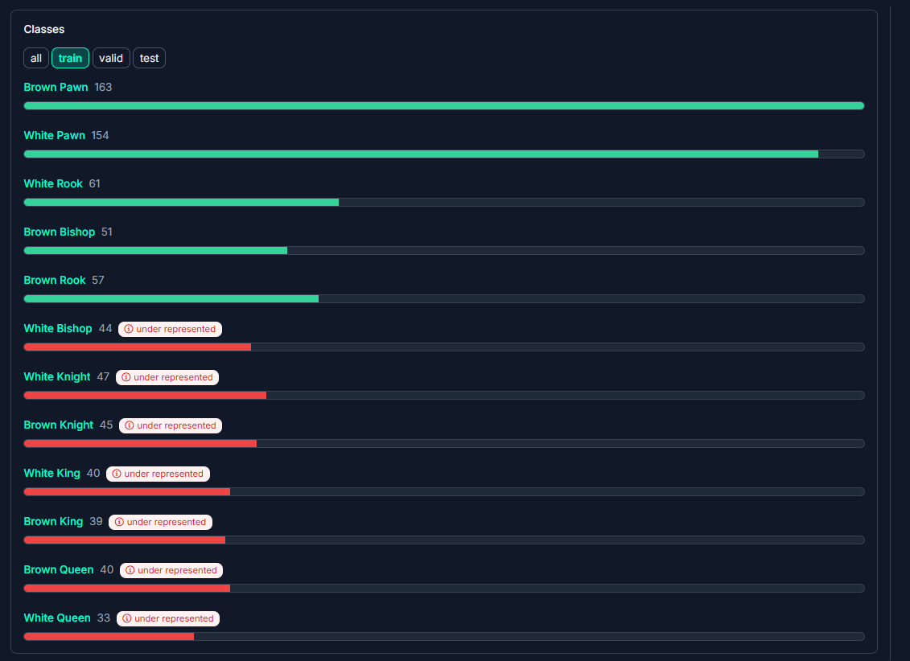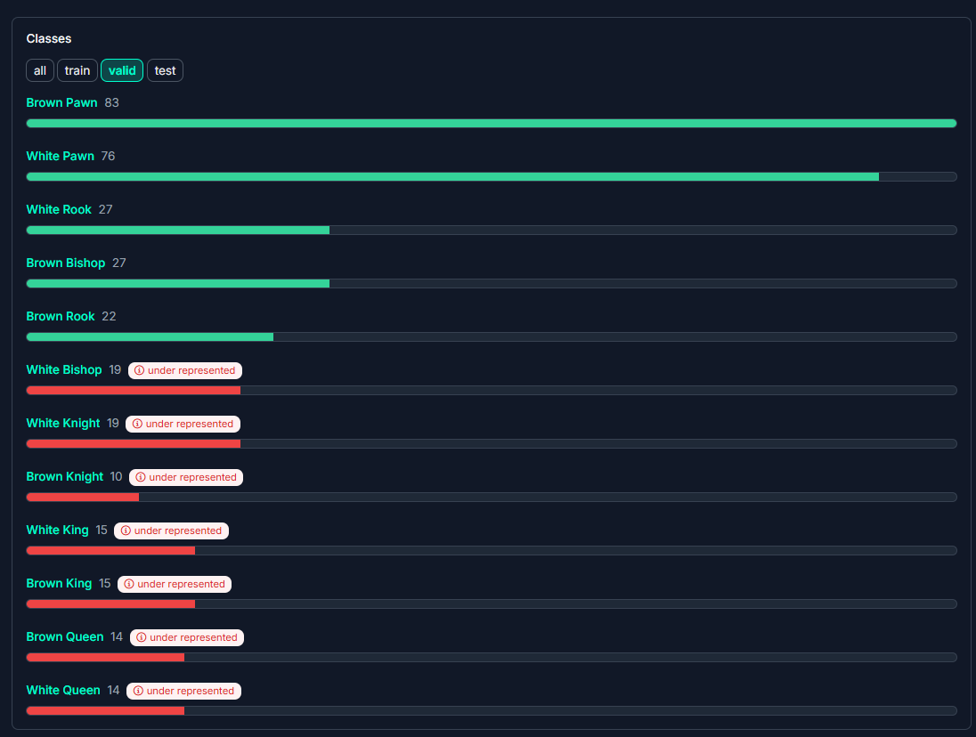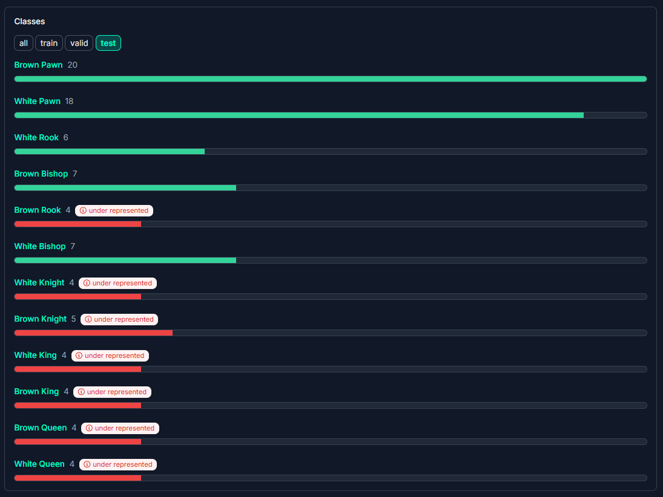

**Dimension Insights:** Overview of the sizes and aspect ratios of the images in your dataset.

* **Size Distribution**
* Sizes are based on the number of pixels in your images.
* All images are the same size, 3024x4032.
* **Aspect Ratio Distribution:** The aspect ratio of your images compares the width vs. the height of your images.

**Annotation Heatmap:** Overview of where your annotations are located in the images in your dataset. (image below)

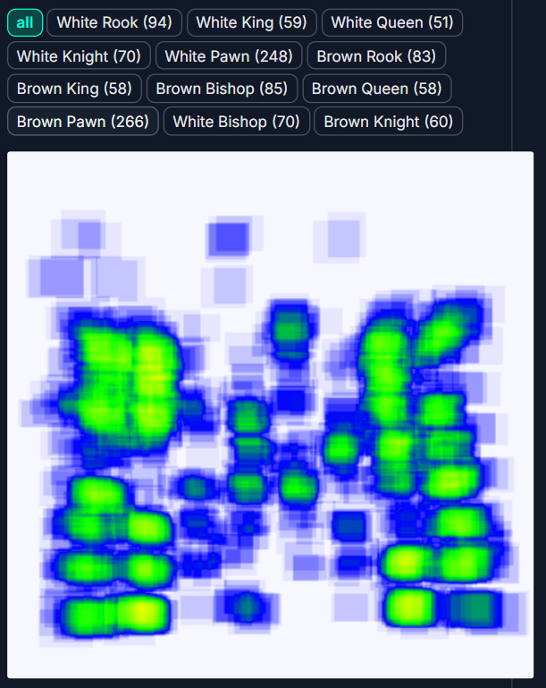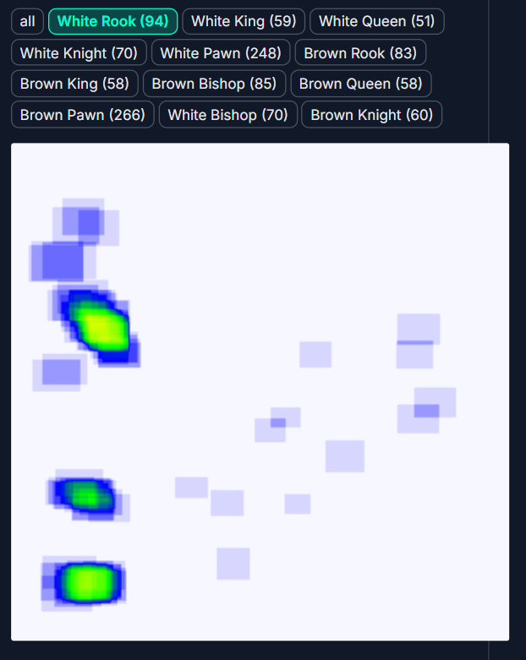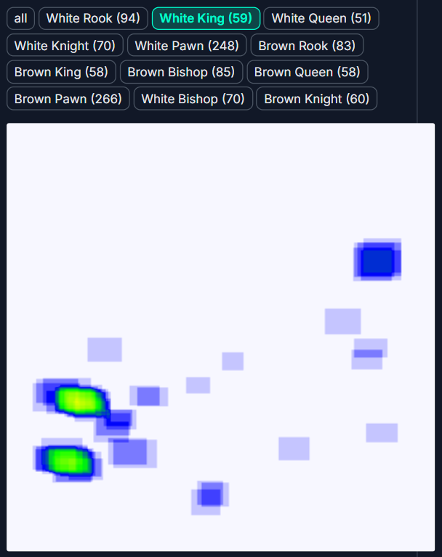

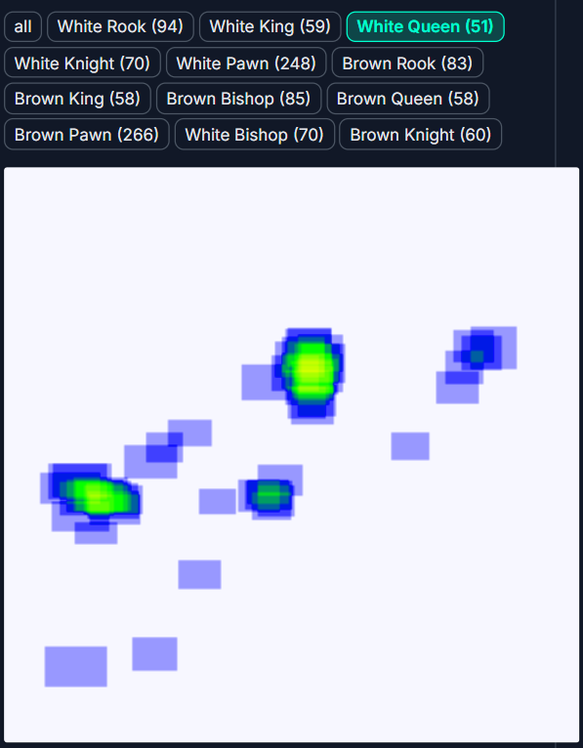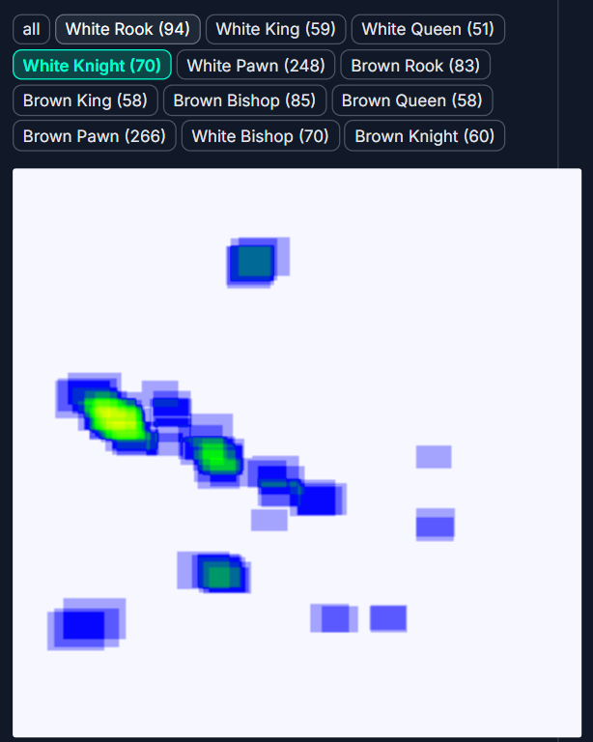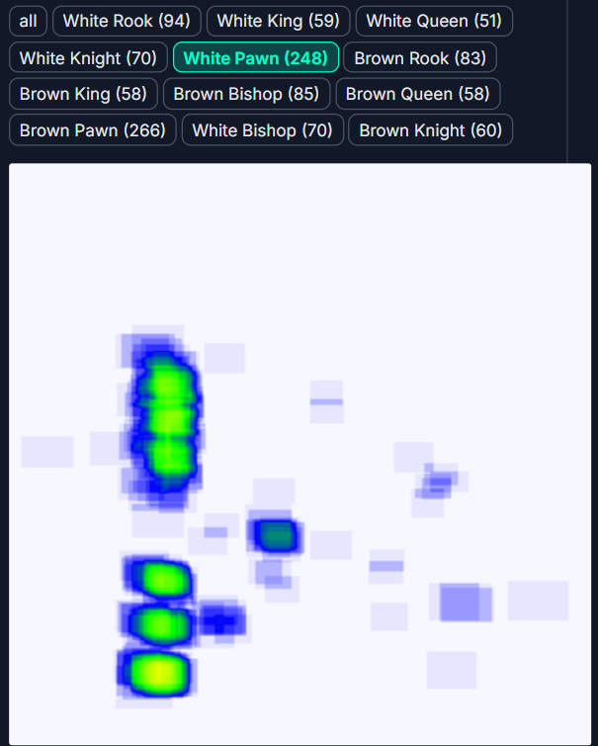

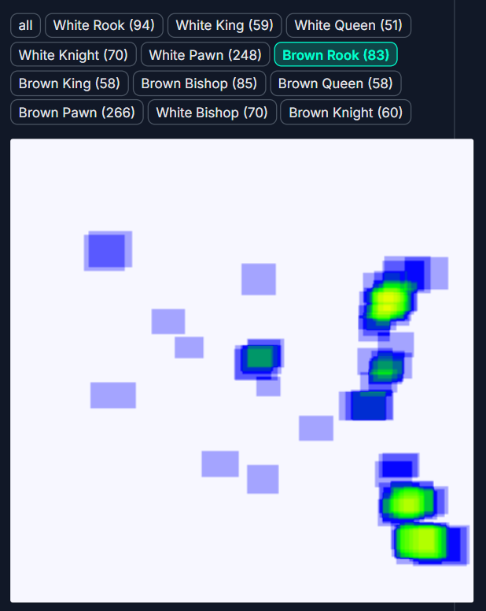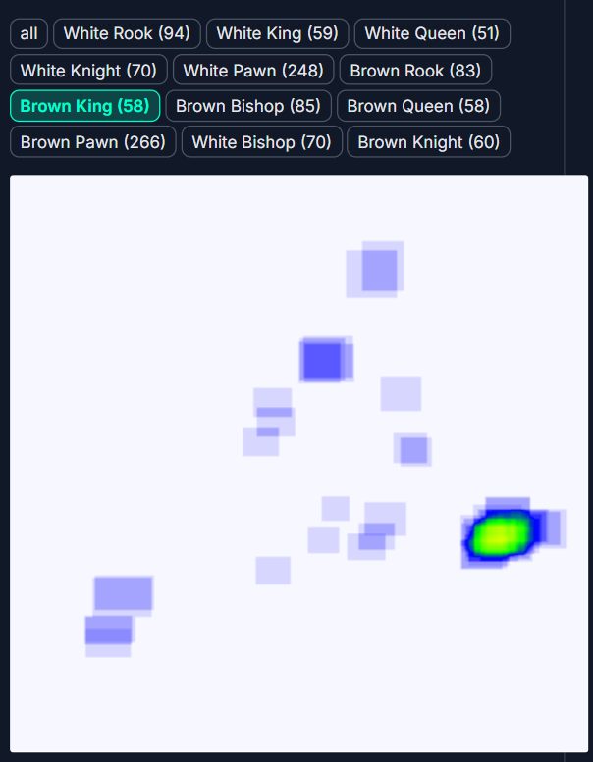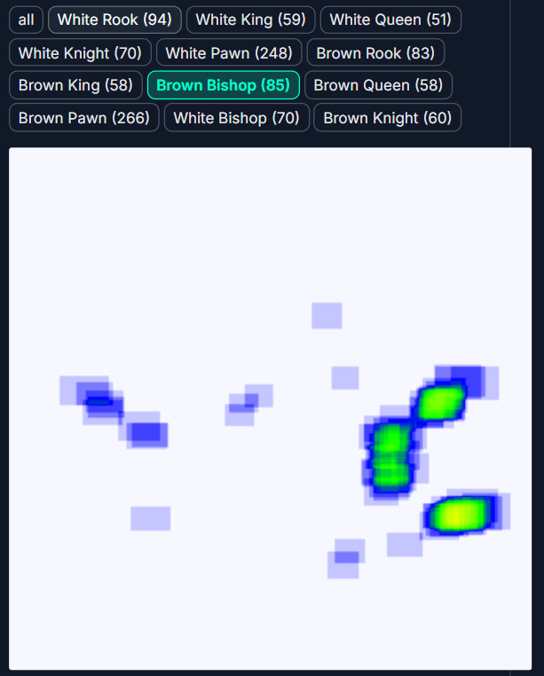

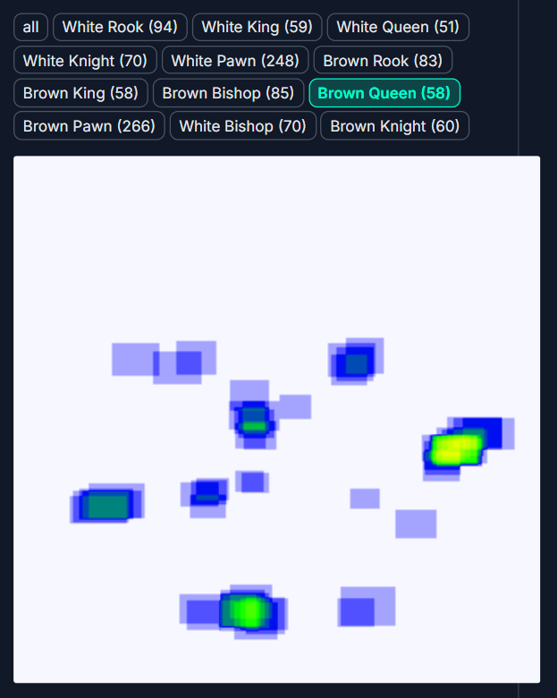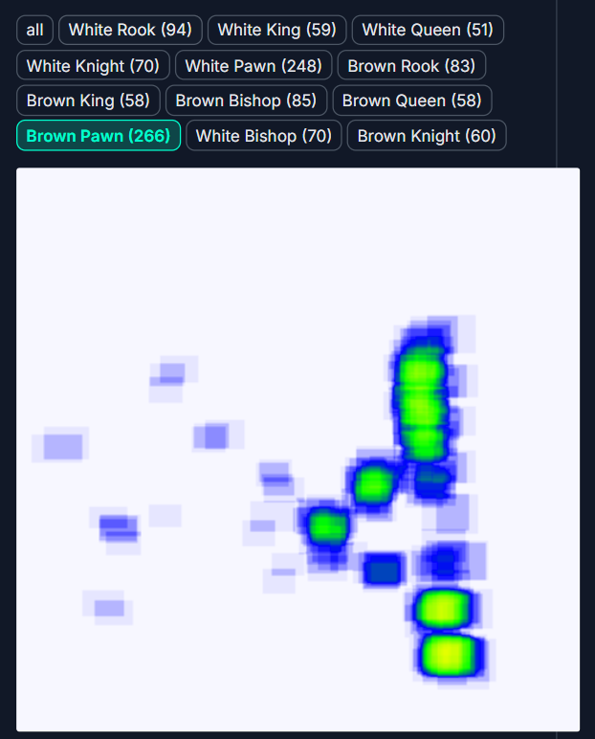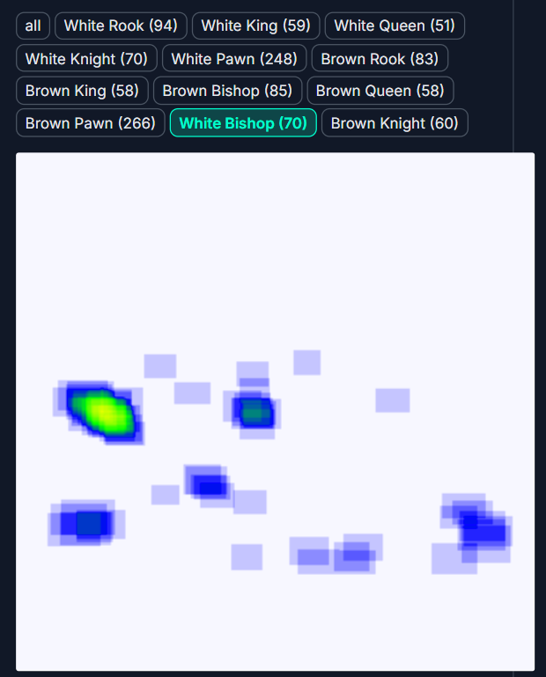

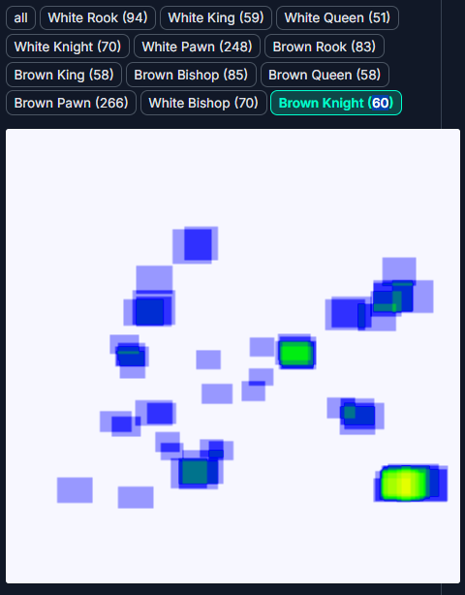

**Histogram of Object Count by Image:** Overview of how many classes are annotated in each image in your dataset. (image below)

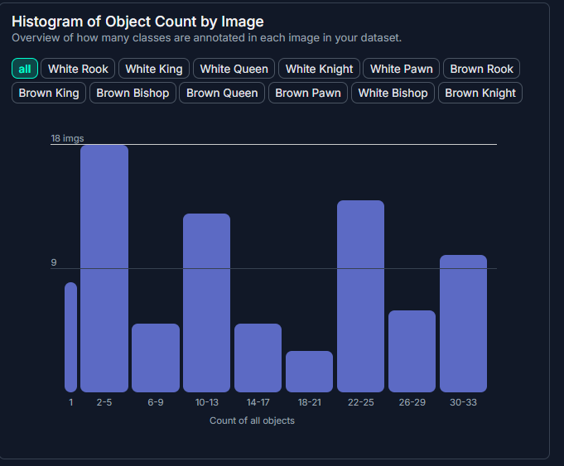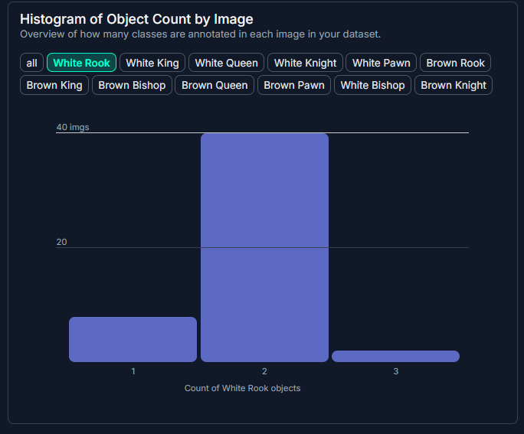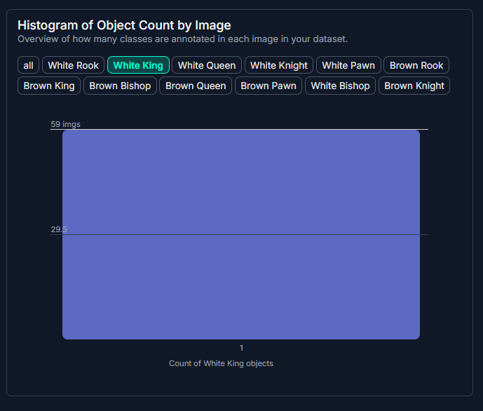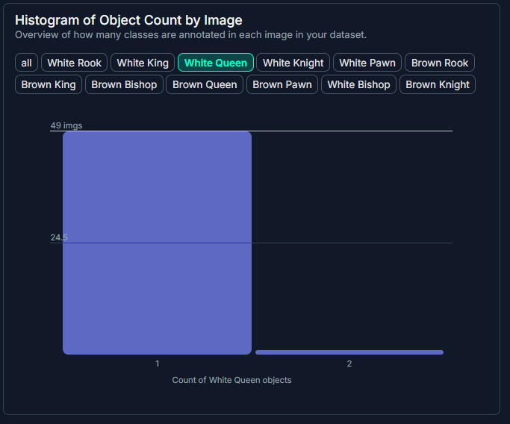

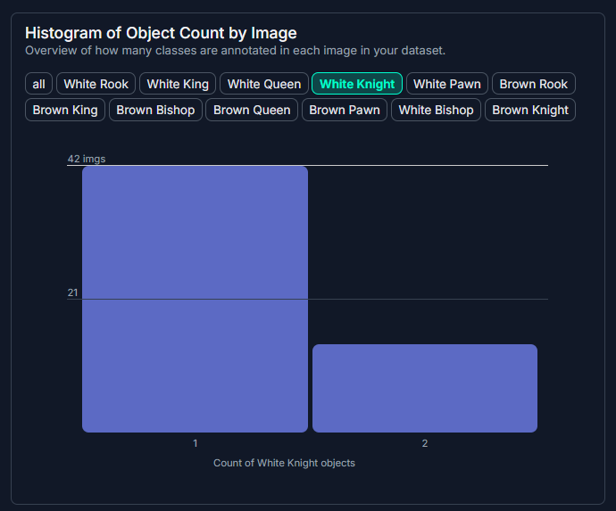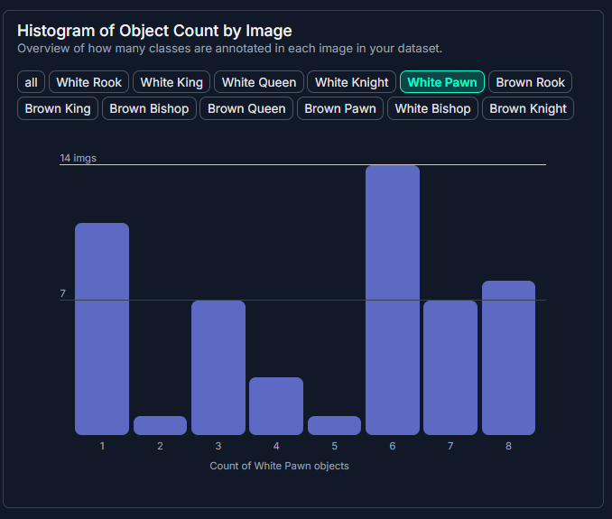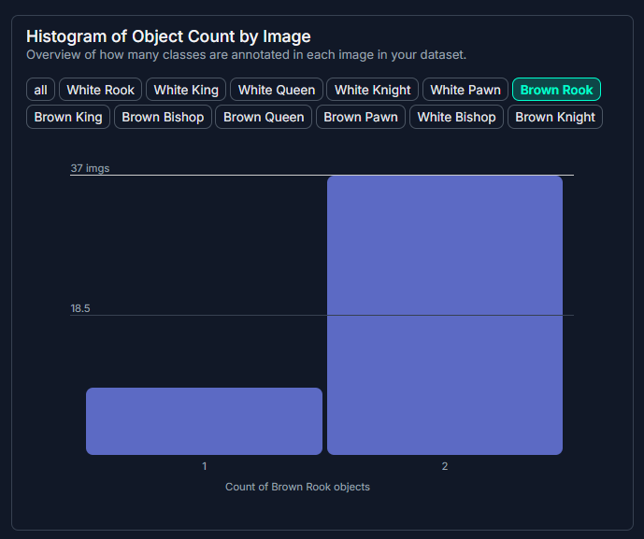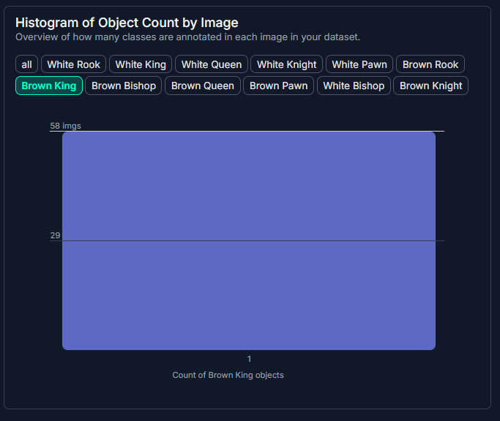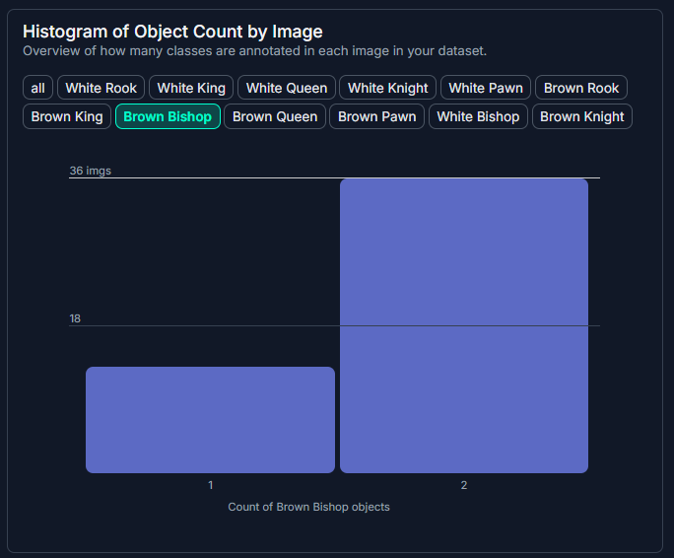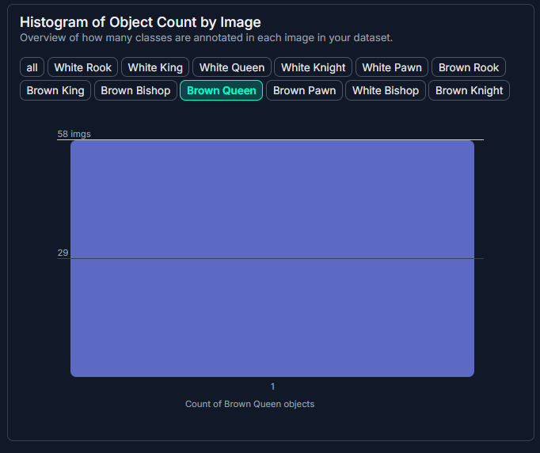

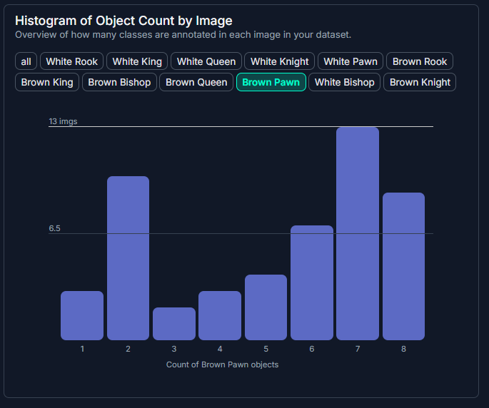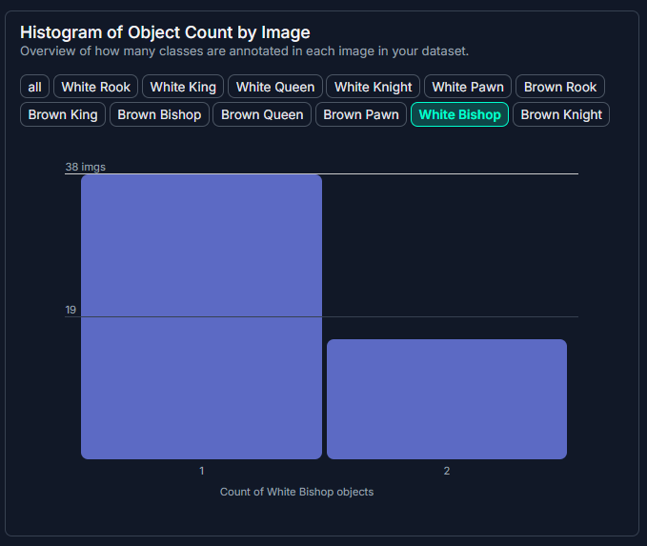

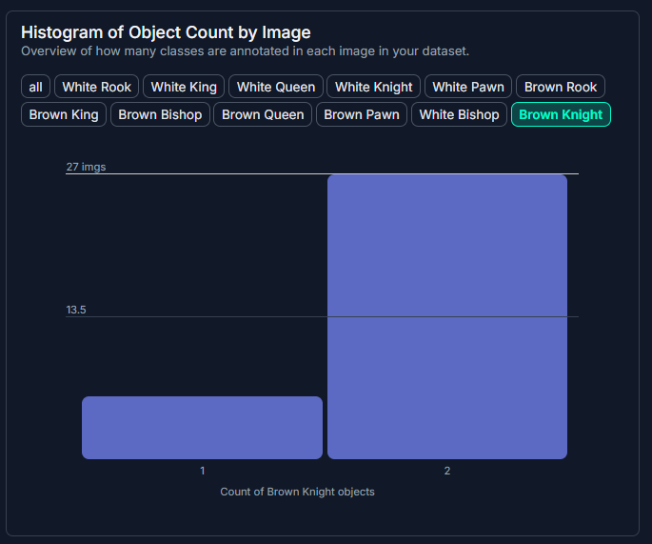

**II. Experiment with YOLOV7**

**1. List of features and file structure:**

1. **File structure:**

**Changes in the source code:**

**Github link:** [**https://github.com/wa1mpls/yolov7/tree/main**](https://github.com/wa1mpls/yolov7/tree/main)

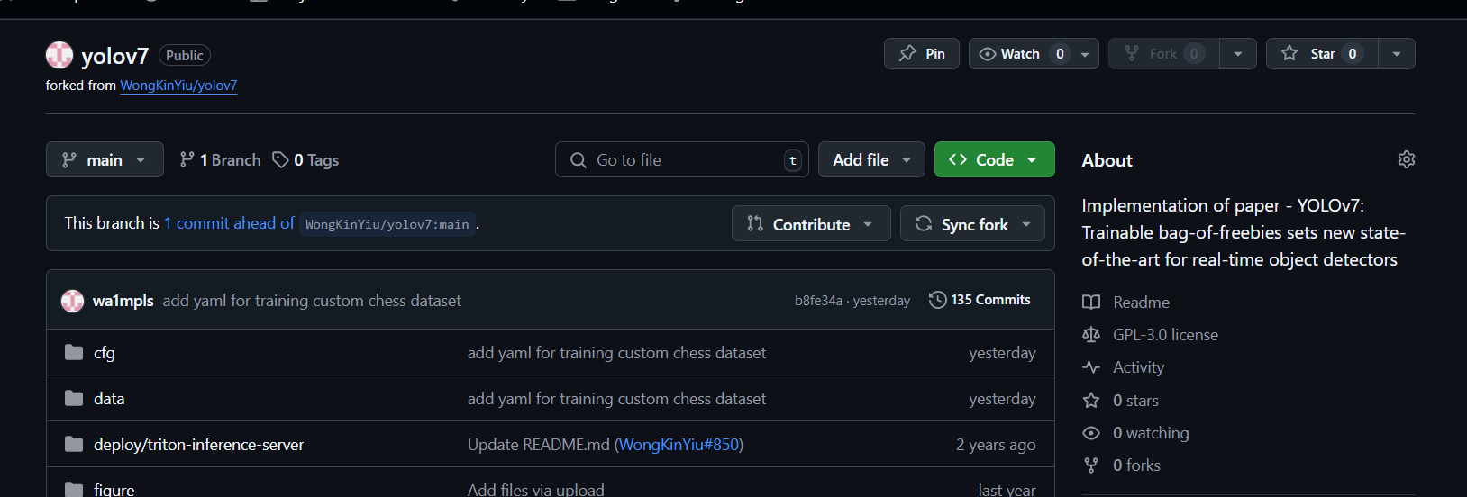

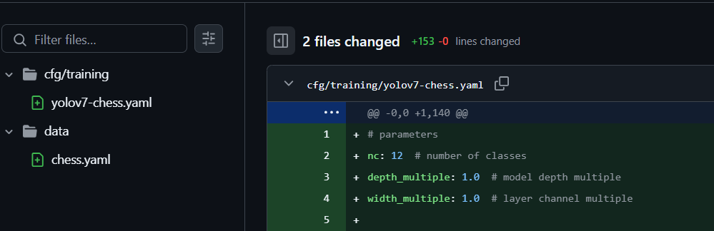

I add two file **in cfg/training folder (yolo7-chess.yaml**) and **data folder (chess.yaml)** as image above to run with the new **Chesspieces dataset.** I only change the part as below

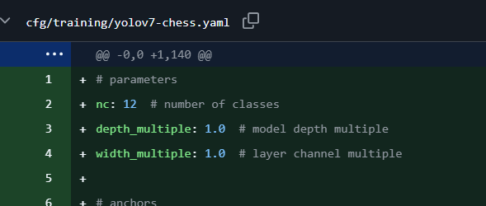

I change number of class into 12 in yolov7-chess.yaml and this part in chess.yaml

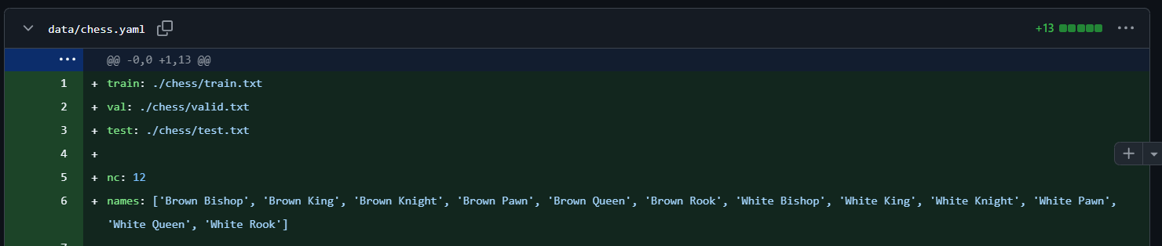

I remain the rest as the origional source.

**Changes in the chess folder when running colab file**

The goal is to organize the Chess folder to follow a specific structure needed for YOLOv7 training (this version required this types of structure – different with yolov11 which I use then). Below is the breakdown of the desired folder structure:

* **images**
  + **train**: Contains training images.
  + **valid**: Contains validation images.
  + **test**: Contains test images.
* **labels**
  + **train**: Contains label files corresponding to the training images.
  + **valid**: Contains label files for the validation images.
  + **test**: Contains label files for the test images.
* **Text Files**
  + **train.txt**: Contains paths to all the training images.
  + **valid.txt**: Contains paths to all the validation images.
  + **test.txt**: Contains paths to all the test images.

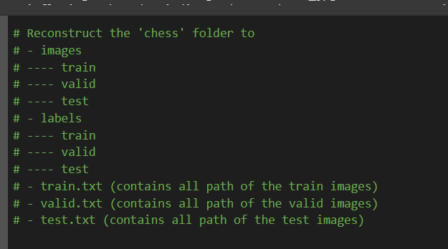

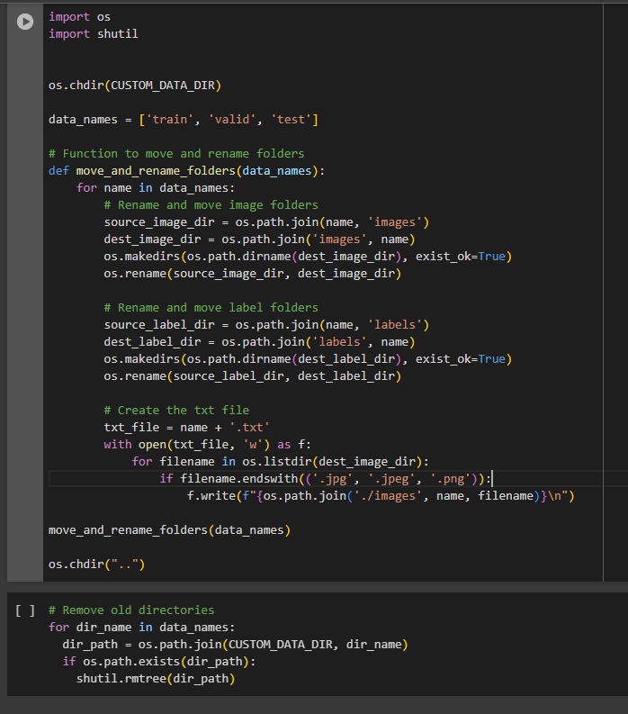

1. **List of functions:**

**Environment and Setup**

* **Checking GPU Availability**
  + **torch.device('cuda' if torch.cuda.is_available() else 'cpu'):** Checks and sets GPU or CPU as the device for PyTorch.
  + **torch.cuda.is_available**(): Verifies if a CUDA-capable GPU is available.
  + **torch.cuda.get_device_name():** Retrieves the name of the GPU in use.
* **Working Directory & Drive**
  + **drive.mount('/content/drive'):** Mounts Google Drive in Colab.
  + **os.makedirs(...):** Creates a directory (if it does not exist).
  + **os.path.exists(...):** Checks if a path exists.
  + **%cd $WORKING_DIR:** Changes the current working directory to a specified path.

**Experiment with YOLOv7**

* **Cloning & Downloading**
  + **!git clone <repo>:** Clones the specified GitHub repository (YOLOv7 code).
  + **!gdown <file_id>:** Downloads files from Google Drive using their file IDs.
  + !**unzip <zipfile>:** Extracts the contents of a ZIP archive.
* **Data Preparation and Organization**
  + **os.rename(...):** Renames (and effectively moves) directories or files.
  + **os.makedirs(...):** Creates directories for images and labels if they don’t exist.
  + **shutil.rmtree(...):** Recursively deletes a directory.
  + **open(...):** Creates and writes to the text files (train.txt, valid.txt, test.txt).
* **Downloading Pre-trained Weights**
  + **!curl -L <url> -o <outputfile>:** Downloads pre-trained weights from the given URL.
* **Demo, Training, and Testing**
  + **!python detect.py --weights ... --conf ... --source ...:** Runs the YOLOv7 detection script on a specified image.
  + **from PIL import Image:** Used to open and display images after detection.
  + **!python train.py --workers ... --device ... --epochs ... --data ... --cfg ... --weights ...:** Trains the YOLOv7 model with custom data.
  + **!python test.py --data ... --weights ...:** Tests/evaluates the trained YOLOv7 model.

1. **Image proof:**

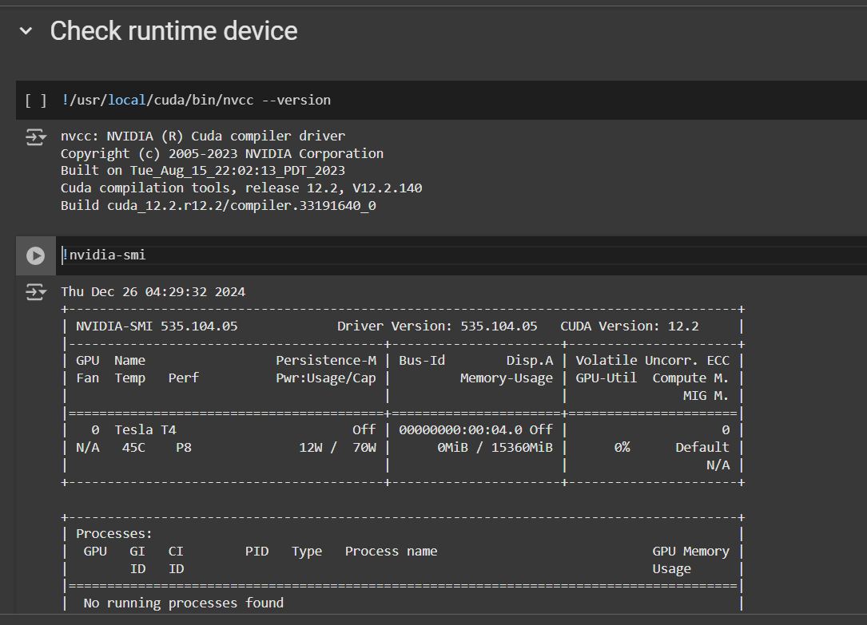

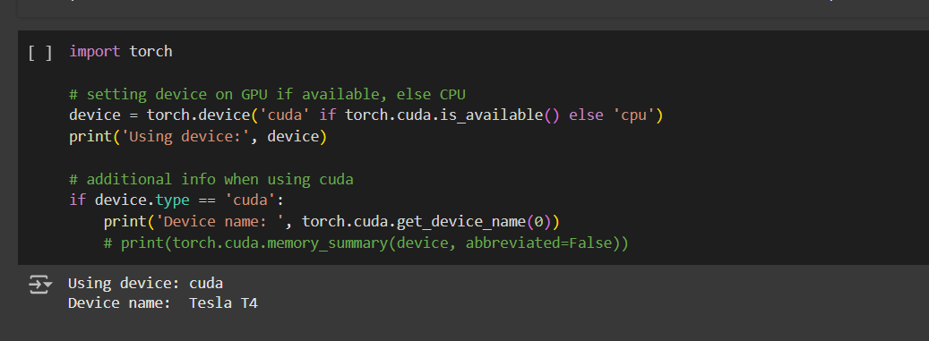

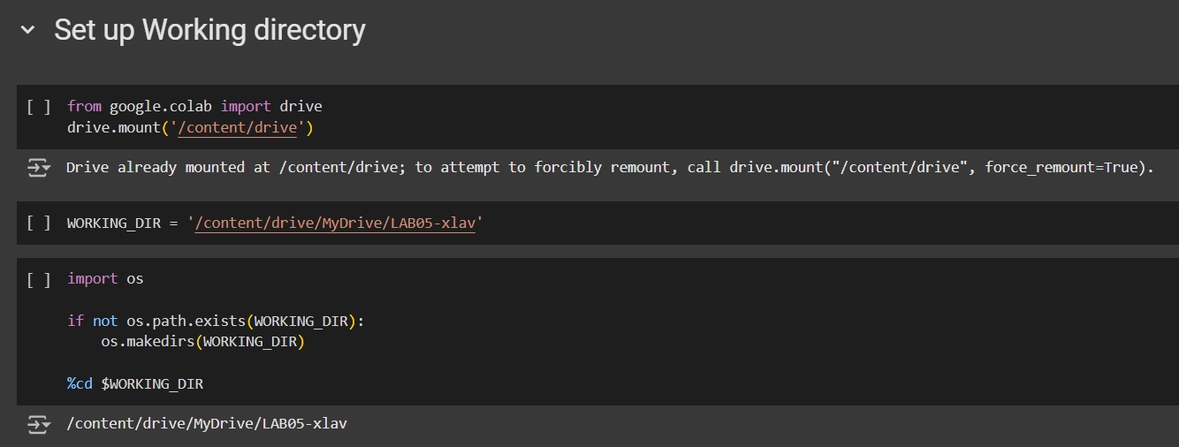

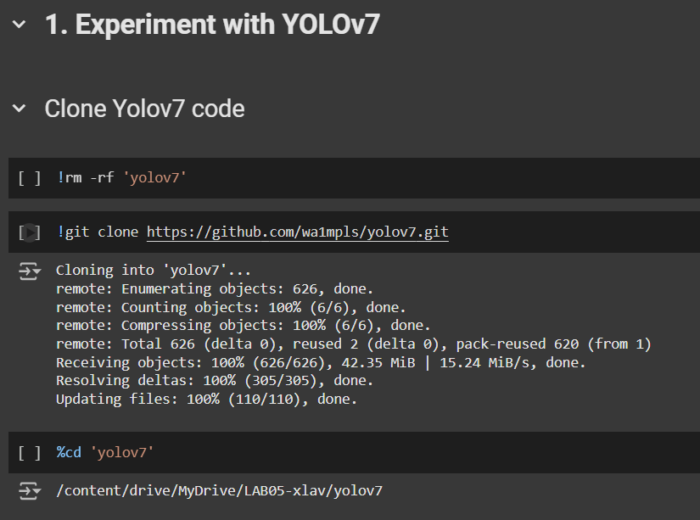

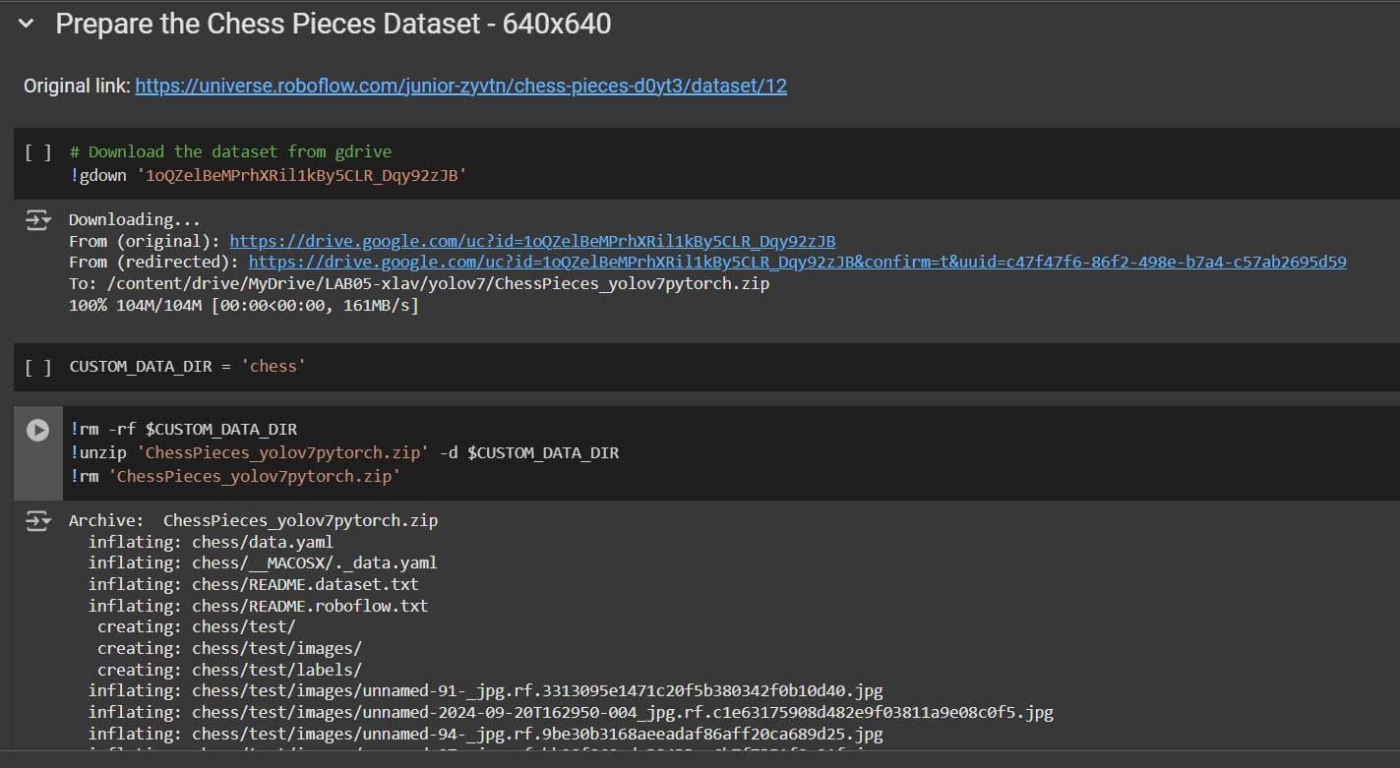

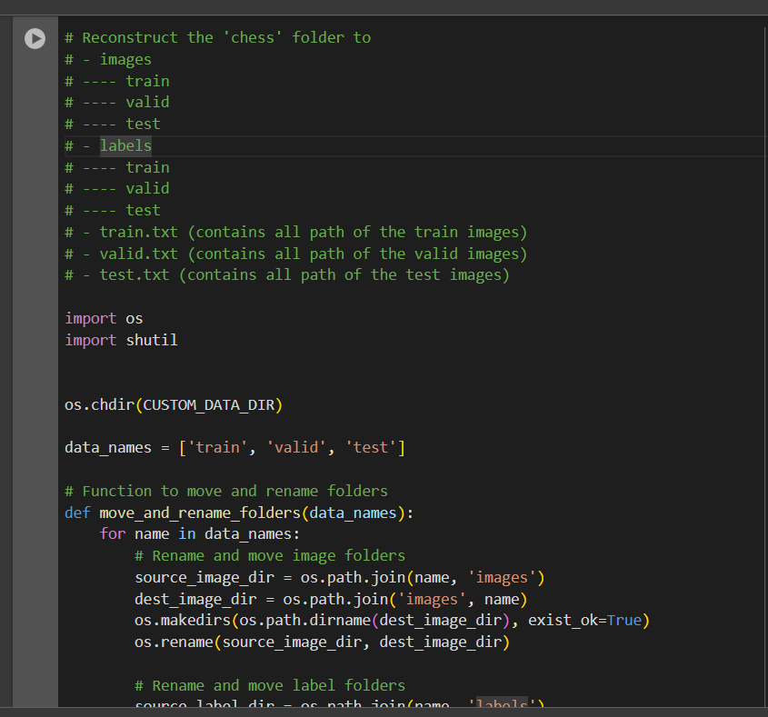

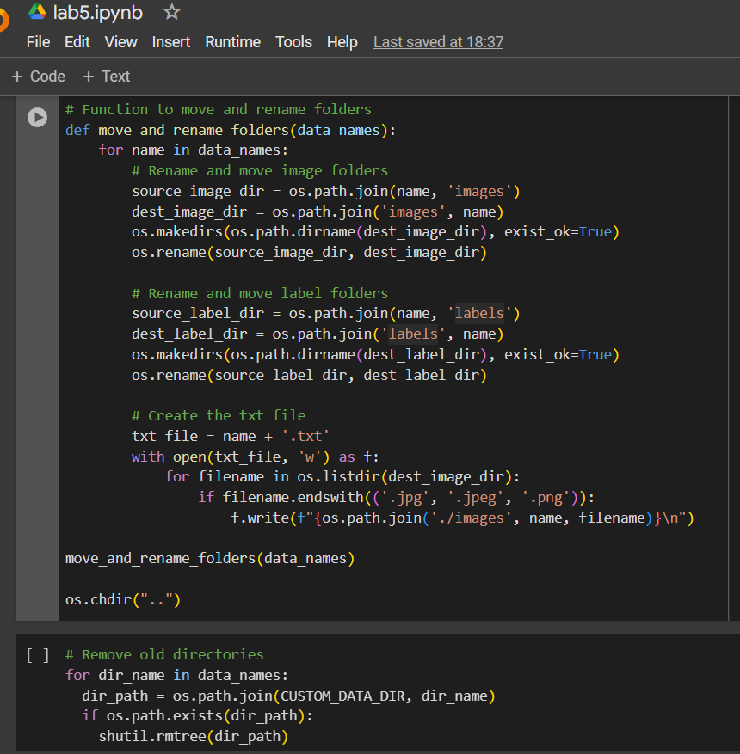

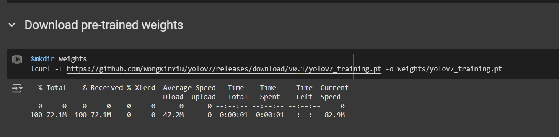

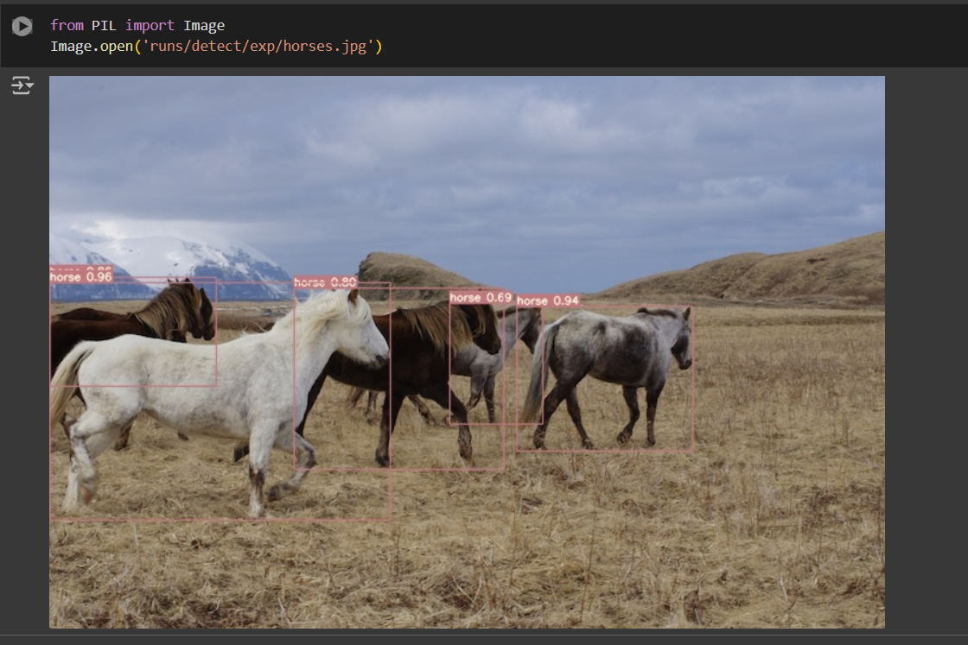

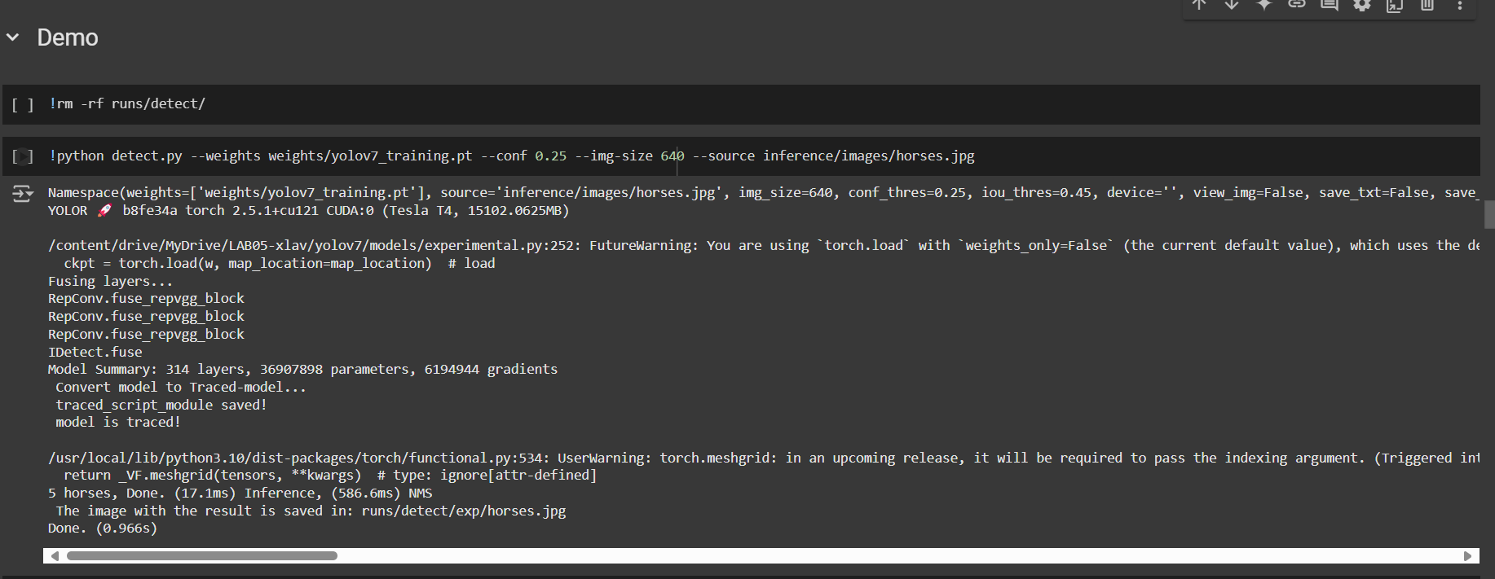

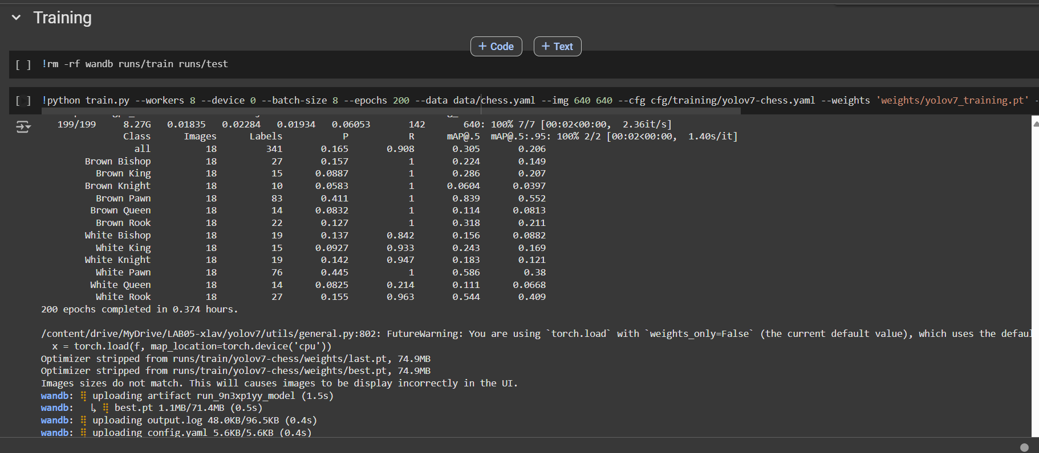

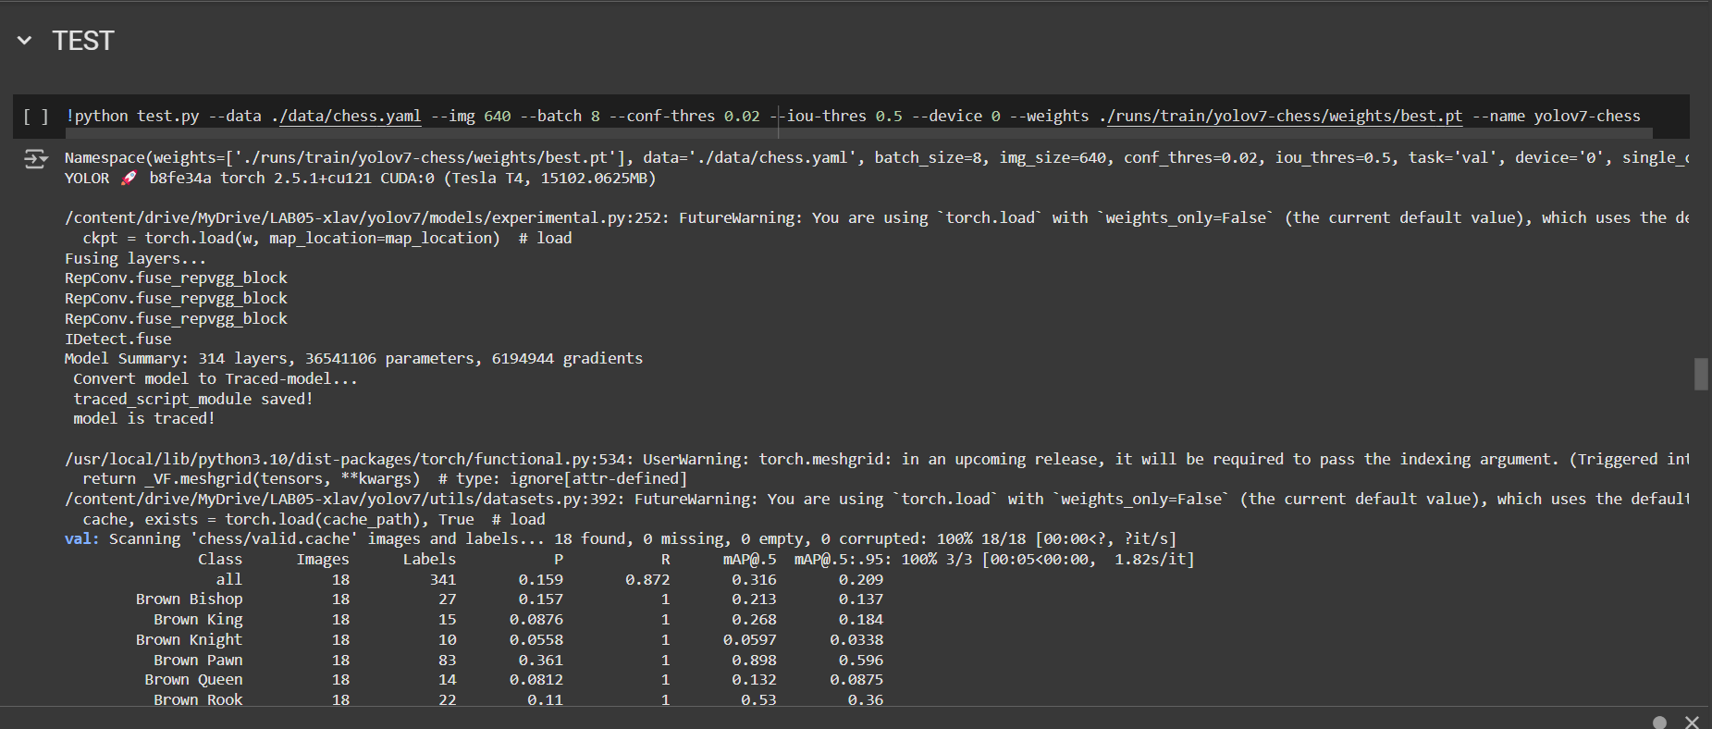

**2. Summary of Function Usage and Explanation**

**1. Clone YOLOv7 Code**

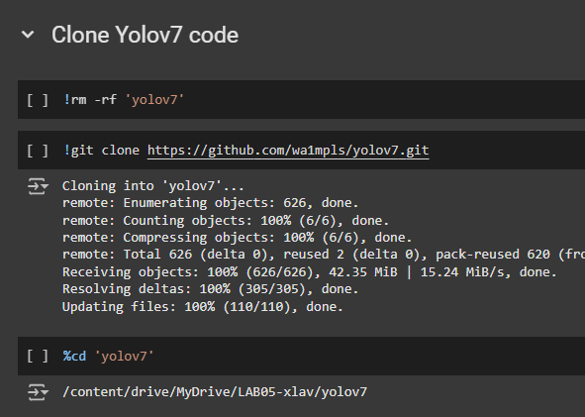

* **!rm -rf 'yolov7'**: This command removes any existing folder named yolov7 to ensure a clean setup.
* **!git clone https://github.com/wa1mpls/yolov7.git**: This command clones the YOLOv7 repository from GitHub into the current directory.
* **%cd 'yolov7'**: This changes the working directory to the yolov7 folder that was just cloned. It ensures that subsequent commands are executed within the YOLOv7 code base.

**2. Prepare the Chess Pieces Dataset**

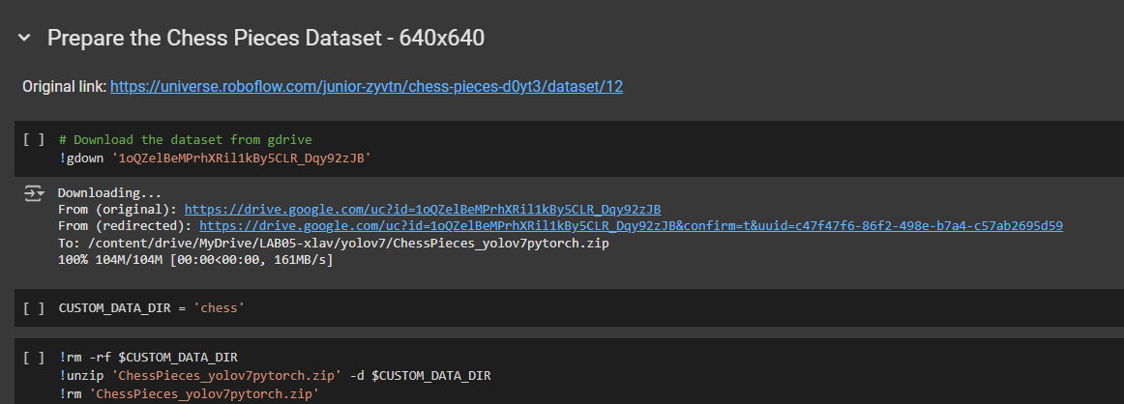

* **!gdown '1oQZelBeMPrhXRil1kBy5CLR_Dqy92zJB'**: This command uses gdown to download a dataset from Google Drive using the provided file ID. The dataset contains images and annotations for training YOLO.
* **CUSTOM_DATA_DIR = 'chess'**: Sets a variable for the directory where the dataset will be unzipped.
* **!rm -rf $CUSTOM_DATA_DIR**: Removes any previous versions of the chess folder, ensuring that the new dataset is extracted cleanly.
* **!unzip 'ChessPieces_yolov7pytorch.zip' -d $CUSTOM_DATA_DIR**: Unzips the downloaded dataset into the specified directory (chess).
* **!rm 'ChessPieces_yolov7pytorch.zip'**: Deletes the zip file after extraction.
* **You need an account to download dataset. It required private API key from Robflow website.**
* 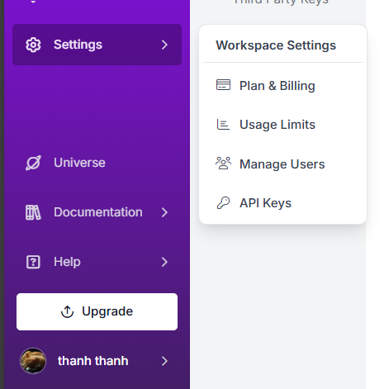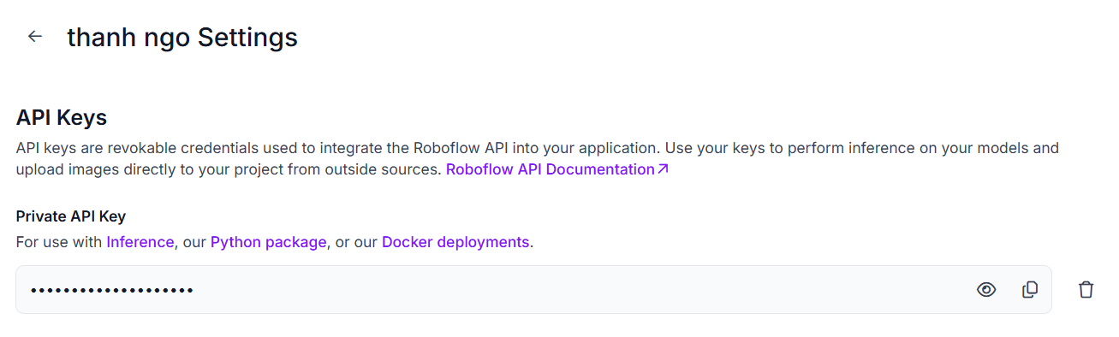

**3. Reorganizing Dataset Folders**

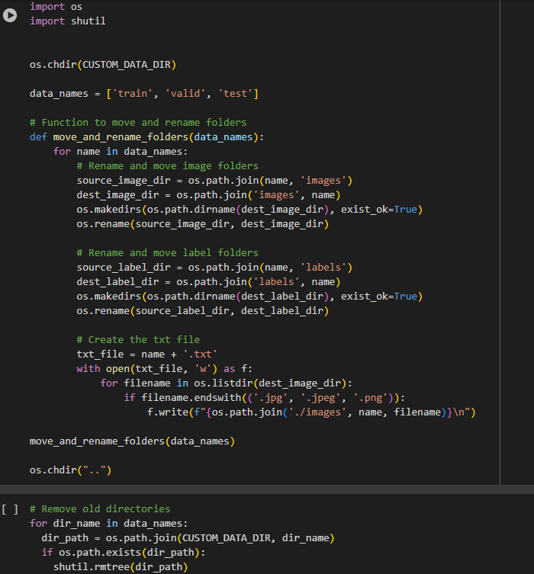

* **os.chdir(CUSTOM_DATA_DIR)**: Changes the current working directory to the folder containing the dataset.
* **data_names = ['train', 'valid', 'test']**: Specifies the three main directories of the dataset: train, valid, and test, which contain images and labels for training, validation, and testing.
* **move_and_rename_folders(data_names)**: This function does the following for each dataset split:
  + **source_image_dir & dest_image_dir**: Moves the images from their original directory to a new directory structure (images/train, images/valid, images/test).
  + **source_label_dir & dest_label_dir**: Moves the label files to corresponding directories (labels/train, labels/valid, labels/test).
  + **txt_file**: For each dataset split (train, valid, test), it creates a .txt file that lists all image file paths, which is required by YOLO for training.

**4. Remove Old Dataset Folders**

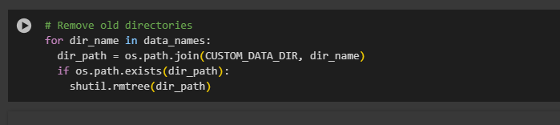

* **os.chdir("..")**: Changes the working directory back to the parent directory.
* **shutil.rmtree(dir_path)**: Deletes any old folders (train, valid, test) that might have existed before the reorganization.

**5. Download Pre-trained Weights**

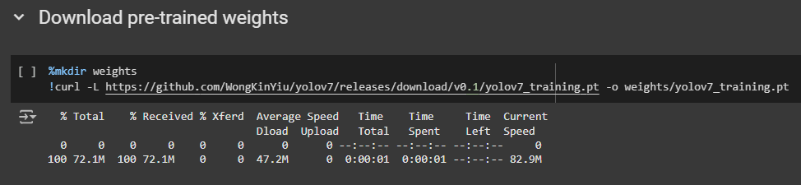

* **%mkdir weights**: Creates a new directory called weights to store the pre-trained weights.
* **!curl -L https://github.com/WongKinYiu/yolov7/releases/download/v0.1/yolov7_training.pt -o weights/yolov7_training.pt**: Uses curl to download the pre-trained weights for YOLOv7 from a GitHub release. These weights help improve the training process by providing a starting point.

**6. Run YOLOv7 Detection**

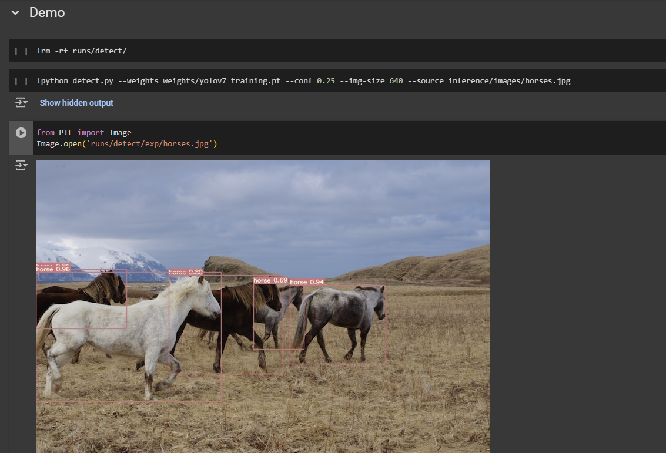

**!rm -rf runs/detect/**: Removes any previous detection results stored in the runs/detect/ directory.

* **!python detect.py**: Runs the detection script using YOLOv7 with the following parameters:
  + **--weights weights/yolov7_training.pt**: Specifies the path to the pre-trained YOLOv7 weights.
  + **--conf 0.25**: Sets the confidence threshold for detection. Objects detected with a confidence score below this value will not be considered.
  + **--img-size 640**: Specifies the image size (640x640) for the input images.
  + **--source inference/images/horses.jpg**: Specifies the input image (horses.jpg) for the detection.
* **Image.open('runs/detect/exp/horses.jpg')**: Opens and displays the detection result using the PIL library.

**7. Train YOLOv7**

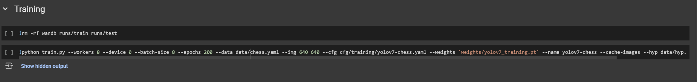

* **!rm -rf wandb runs/train runs/test**: Removes previous training results and logs.
* **!python train.py**: Starts the training process with YOLOv7, using the following parameters:
  + **--workers 8**: Specifies the number of data loading workers to speed up data loading.
  + **--device 0**: Specifies which GPU to use (device 0, the first GPU).
  + **--batch-size 8**: Sets the batch size to 8 images per training iteration.
  + **--epochs 200**: Specifies the number of epochs to train the model (200).
  + **--data data/chess.yaml**: Specifies the path to the dataset configuration file (chess.yaml), which contains details about the dataset (number of classes, paths, etc.).
  + **--img 640 640**: Specifies the input image size (640x640).
  + **--cfg cfg/training/yolov7-chess.yaml**: Specifies the YOLOv7 model configuration for this task.
  + **--weights 'weights/yolov7_training.pt'**: Specifies the pre-trained weights for fine-tuning.
  + **--name yolov7-chess**: Defines a name for this training session.
  + **--cache-images**: Caches the images to speed up training.
  + **--hyp data/hyp.scratch.custom.yaml**: Specifies a custom hyperparameter configuration file for training. (if you want to adjust other hyparameter like learning rates, batch size,… Do it in this file)

**8. Test YOLOv7**

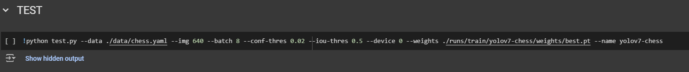

**!python test.py**: Tests the trained YOLOv7 model with the following parameters:

* + **--data ./data/chess.yaml**: Specifies the dataset configuration.
  + **--img 640**: Specifies the input image size for testing.
  + **--batch 8**: Specifies the batch size during testing.
  + **--conf-thres 0.02**: Sets the confidence threshold for detections.
  + **--iou-thres 0.5**: Sets the intersection-over-union (IoU) threshold for valid detections.
  + **--device 0**: Specifies which GPU to use.
  + **--weights ./runs/train/yolov7-chess/weights/best.pt**: Specifies the best weights from the training session.
  + **--name yolov7-chess**: Defines the name for this test session.

**3. Results and Evaluations**

1. **Results:**
2. **Demo:**

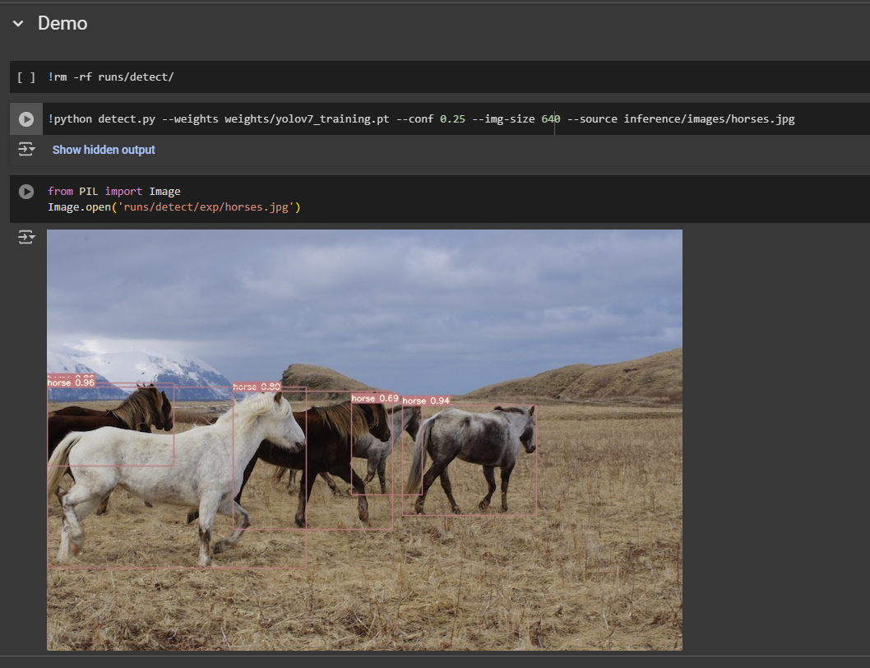

**b) Training: (epochs = 200)**

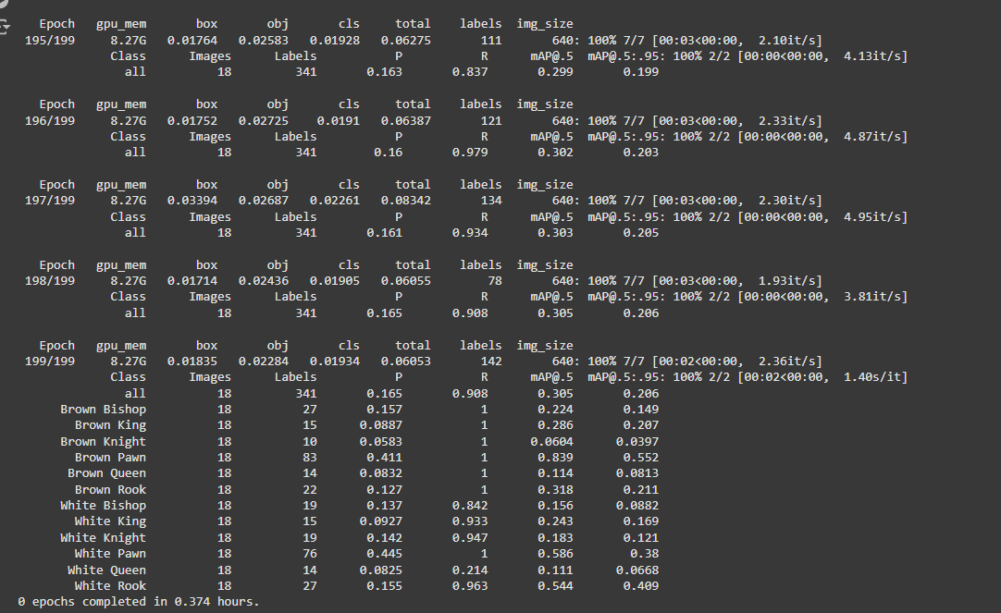

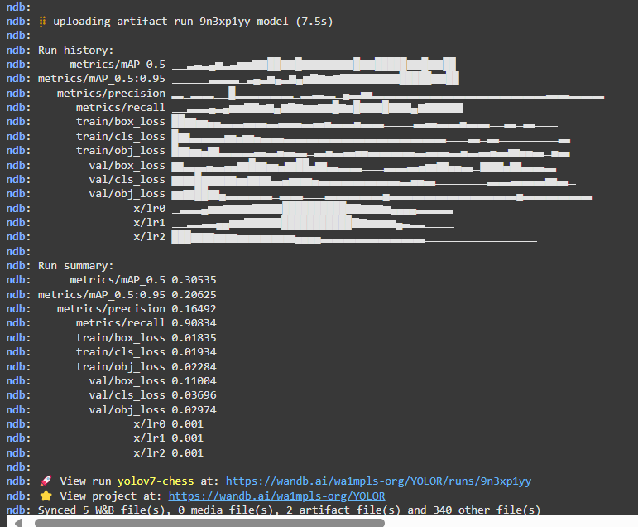

**View train detail in** : <https://wandb.ai/wa1mpls-org/YOLOR/runs/9n3xp1yy?nw=nwuserwa1mpls>

This mean you need an account to login

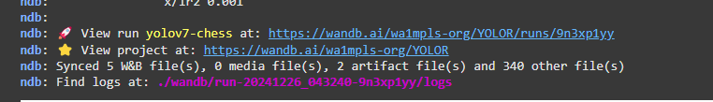

In that link I have some pictures as below:

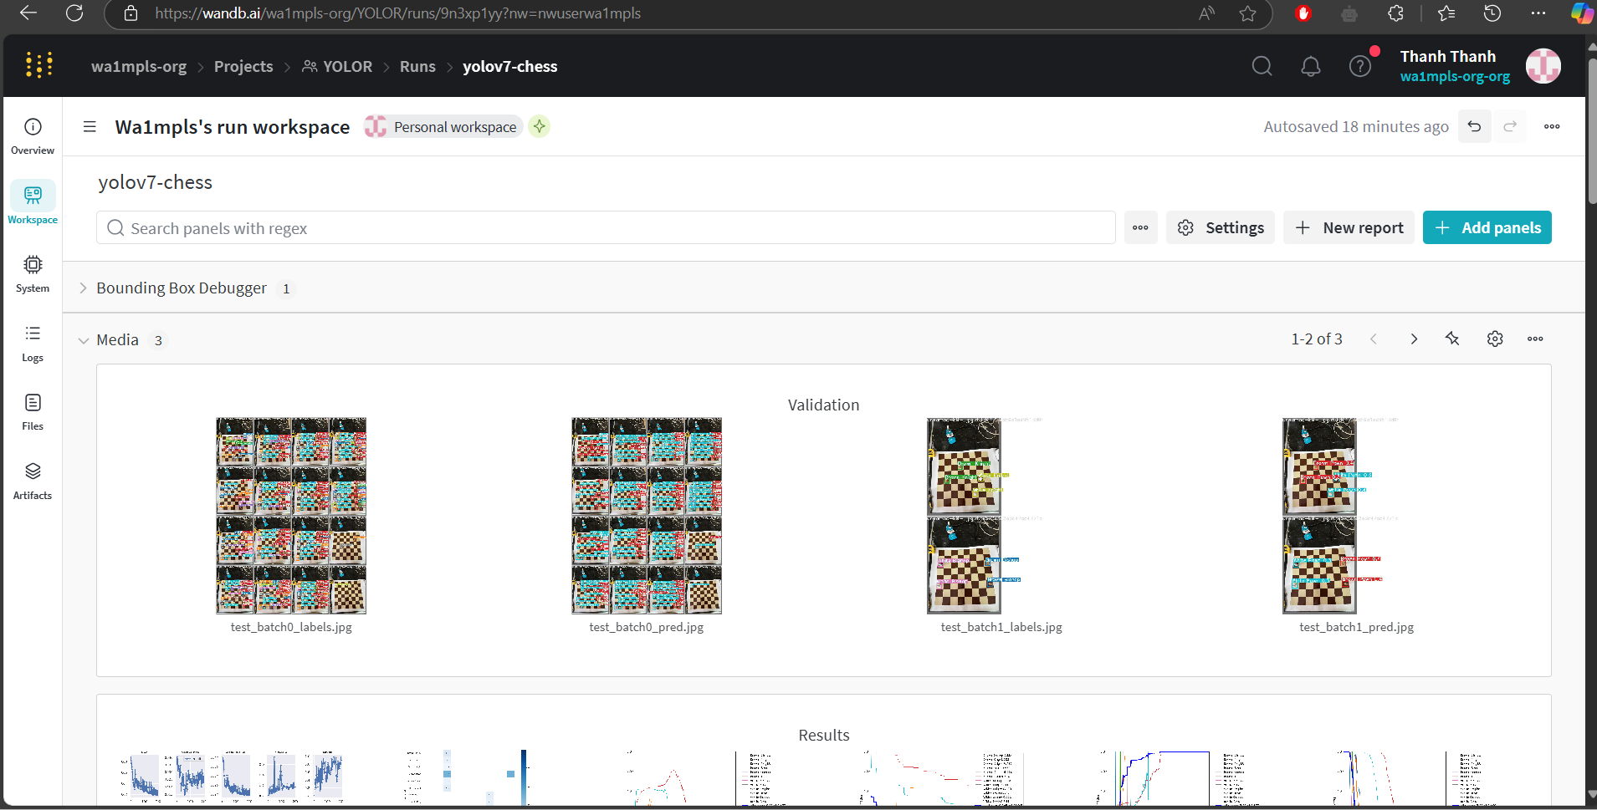

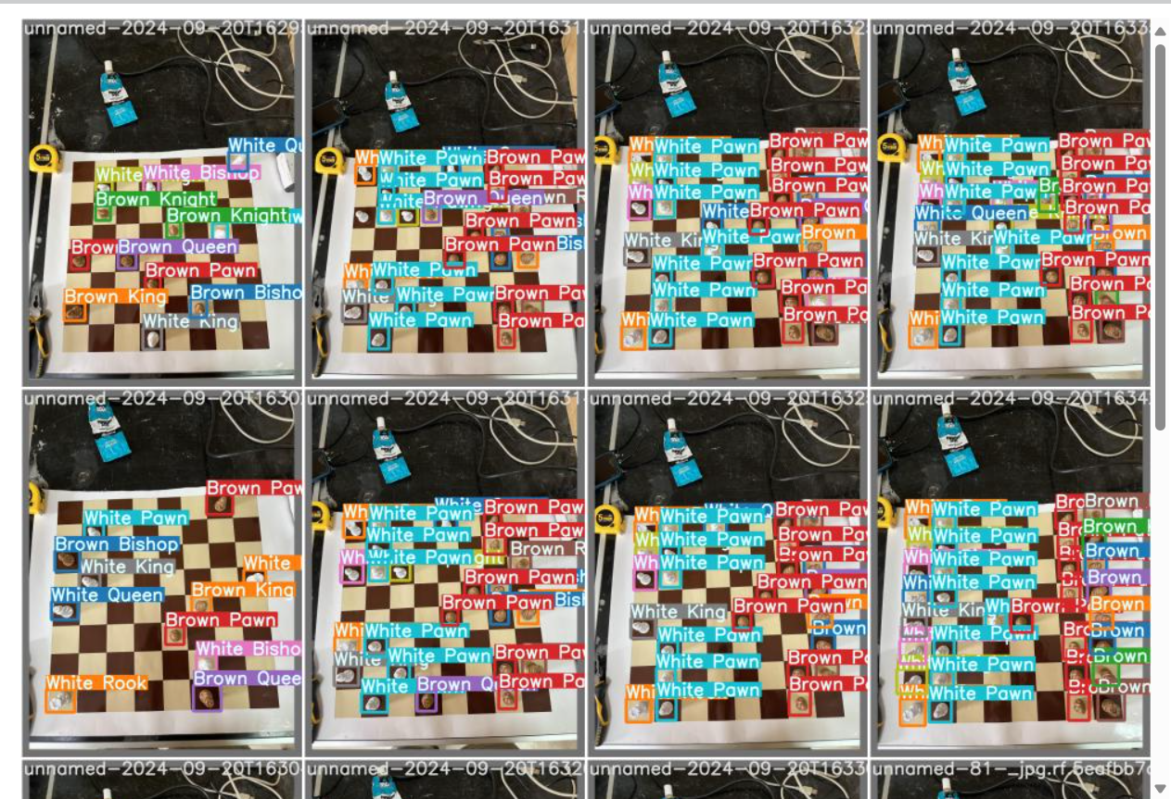

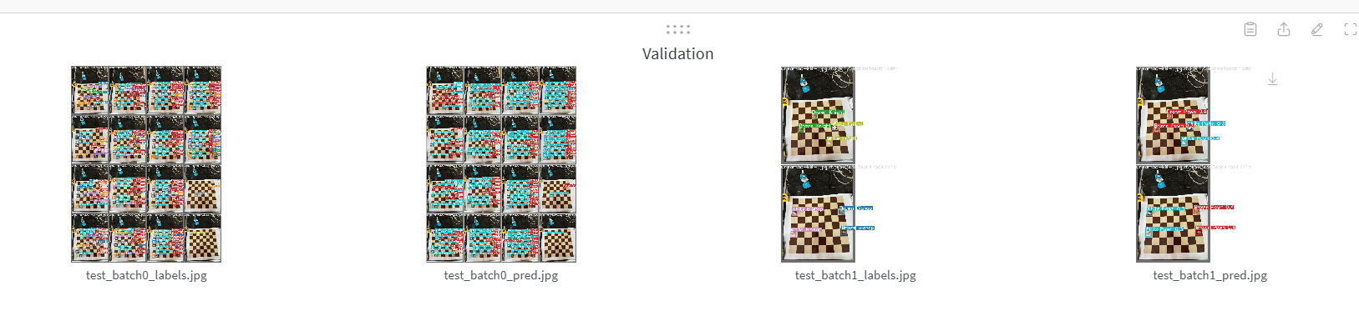

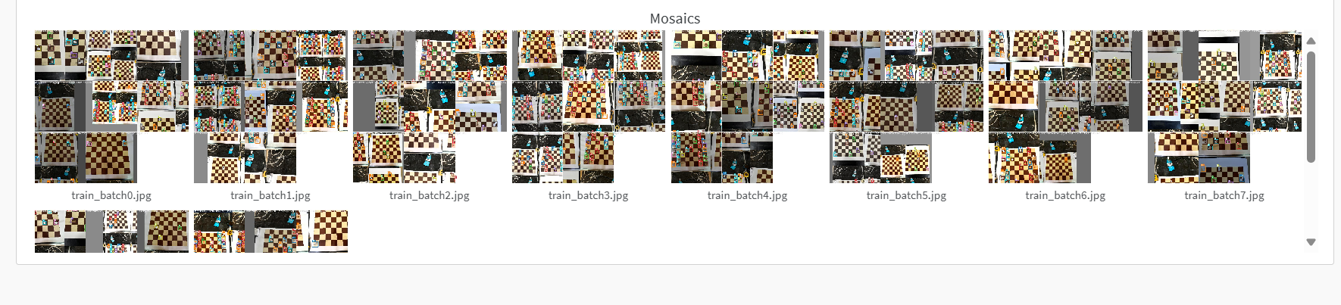

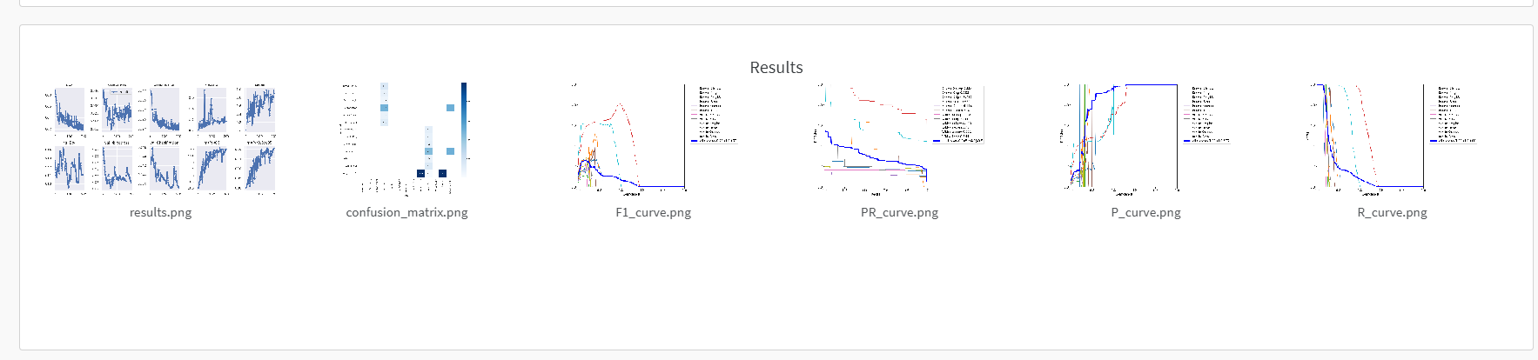

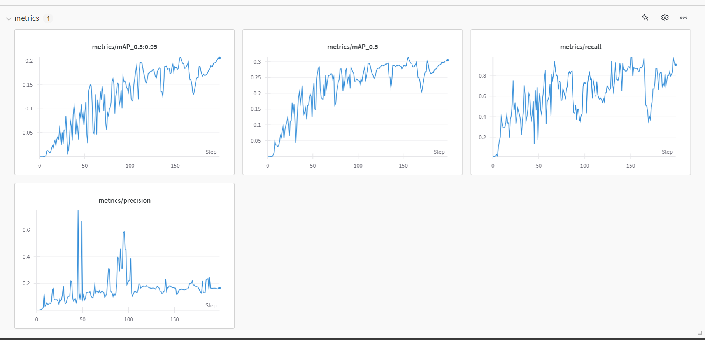

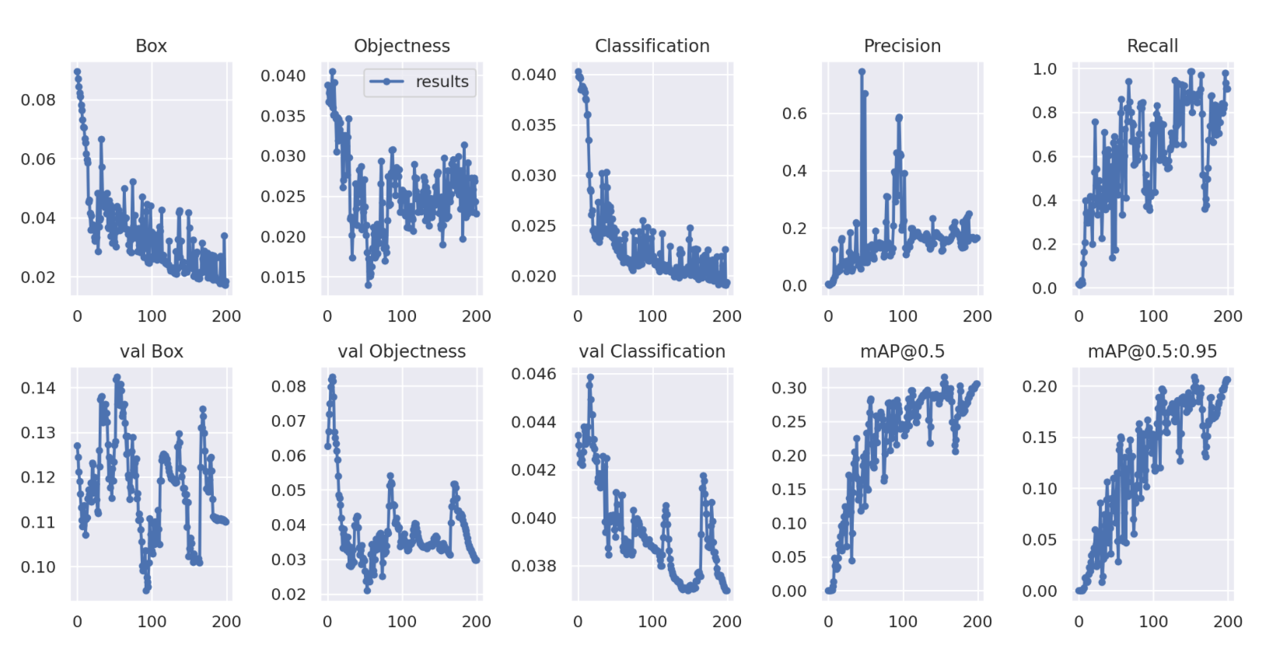

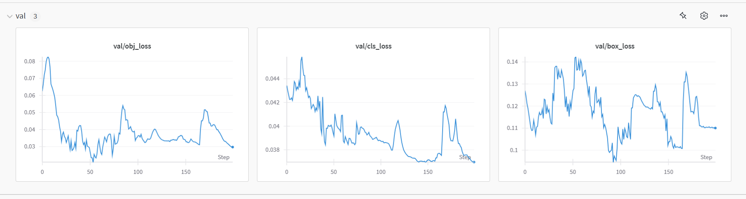

**c) Testing**

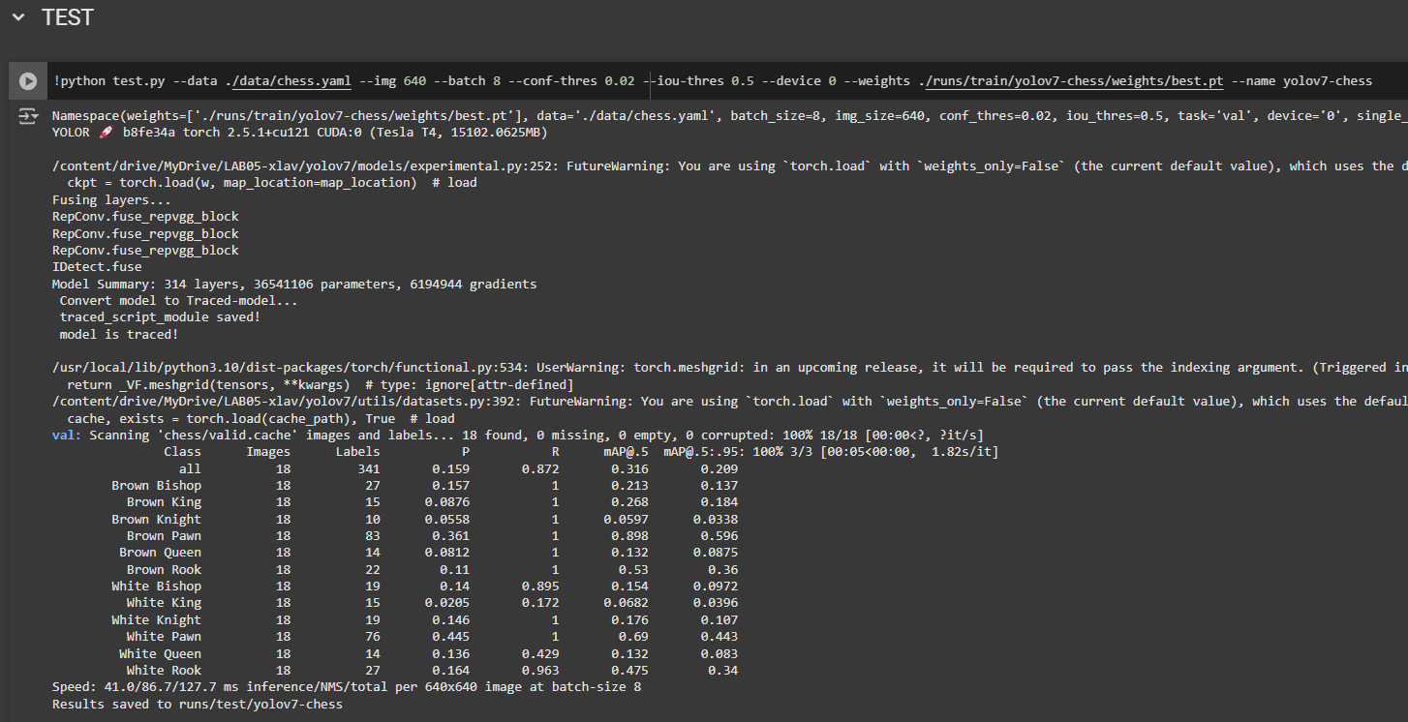

Open folder below to see results: **run/test/yolov7-chess.**

In the yolov11 I did this part. If you want to know. Read the yolov11 part.

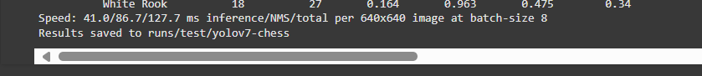

**B. Evaluation**

After running for 200 epochs, the results from YOLOv7 were not satisfactory, as shown below:

**YOLOv7 Run Summary**:

wandb: metrics/mAP_0.5 0.30535

wandb: metrics/mAP_0.5:0.95 0.20625

wandb: metrics/precision 0.16492

wandb: metrics/recall 0.90834

wandb: train/box_loss 0.01835

wandb: train/cls_loss 0.01934

wandb: train/obj_loss 0.02284

wandb: val/box_loss 0.11004

wandb: val/cls_loss 0.03696

wandb: val/obj_loss 0.02974

wandb: x/lr0 0.001

wandb: x/lr1 0.001

wandb: x/lr2 0.001

The results show that after 200 epochs, YOLOv7 still struggled with relatively low performance, especially with precision (0.16492) and mAP (mean Average Precision) of 0.30535 at IoU 0.5. Additionally, the training took a long time.

**III. EXPERIMENT WITH YOLOV11**

**1. List of features and file structure:**

1. **File structure:**

I use the library version of yolov11. So I don’t have specific file structures here.

1. **List of functions:**

**Experiment with YOLOv11 (Ultralytics)**

* **Installation & Checks**
  + **%pip install <packages>:** Installs the required packages (ultralytics, supervision, roboflow).
  + **ultralytics.checks():** Verifies that the Ultralytics environment is correctly set up.
* **Roboflow Integration**
  + **from roboflow import Roboflow:** Imports the Roboflow client library.
  + **rf = Roboflow(api_key=...):** Creates a new Roboflow instance using an API key.
  + **project = rf.workspace("...").project("..."): Retrieves** a specific project.
  + **version = project.version(12):** Gets a particular version of the project.
  + **version.download("yolov11"):** Downloads the dataset in YOLOv11 format.
* **YOLOv11 CLI Commands**
  + **!yolo task=detect mode=predict model=... source**=...: Runs inference with YOLOv11 on an image.
  + **!yolo task=detect mode=train model=... data=... epochs=...:** Trains a YOLOv11 model using the specified data and parameters.
  + **!yolo task=detect mode=val model=... data=...:** Validates the YOLOv11 model on the test set.
  + **IPyImage(filename=...):** Displays images directly in the Colab notebook.

1. **Image proof:**

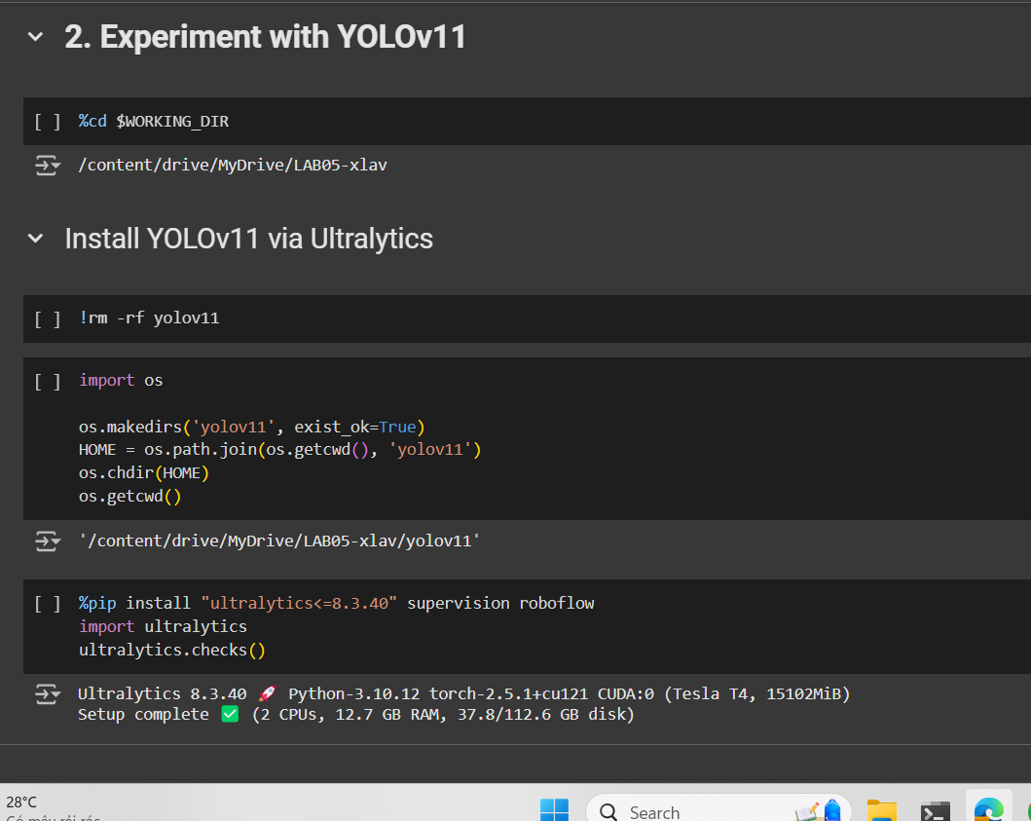

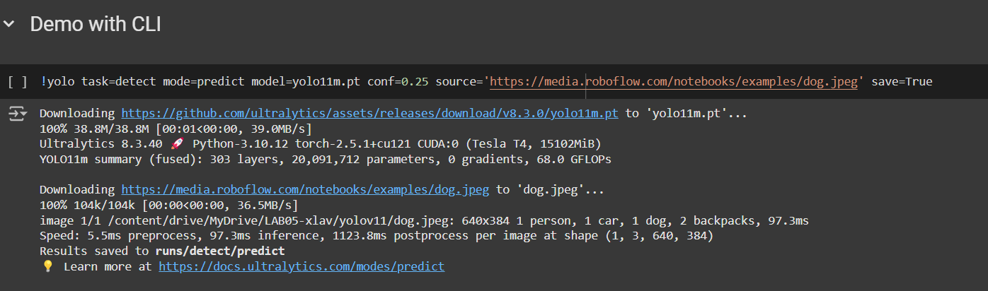

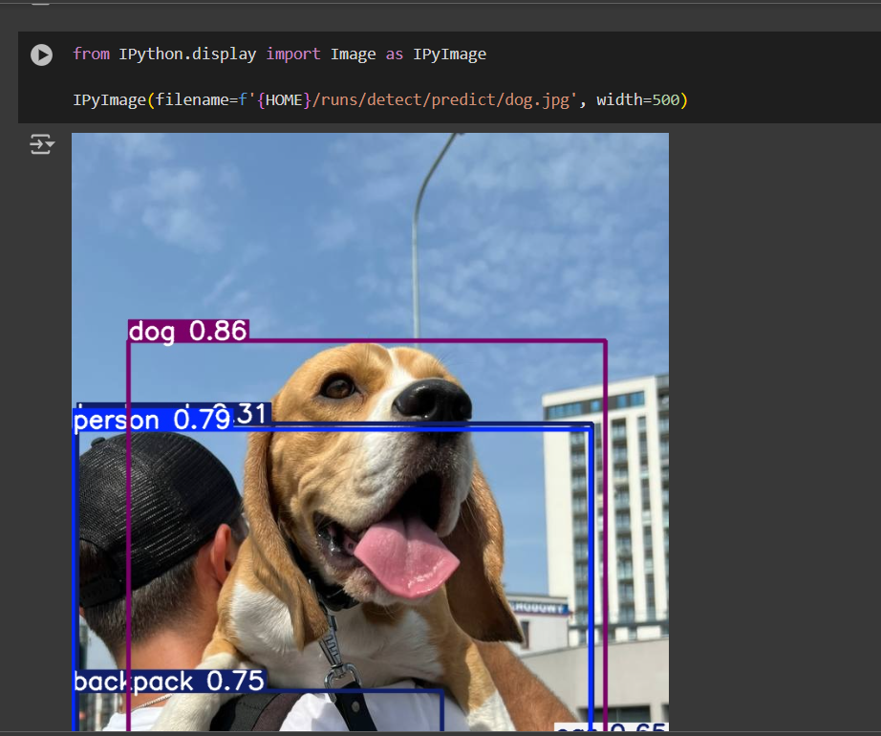

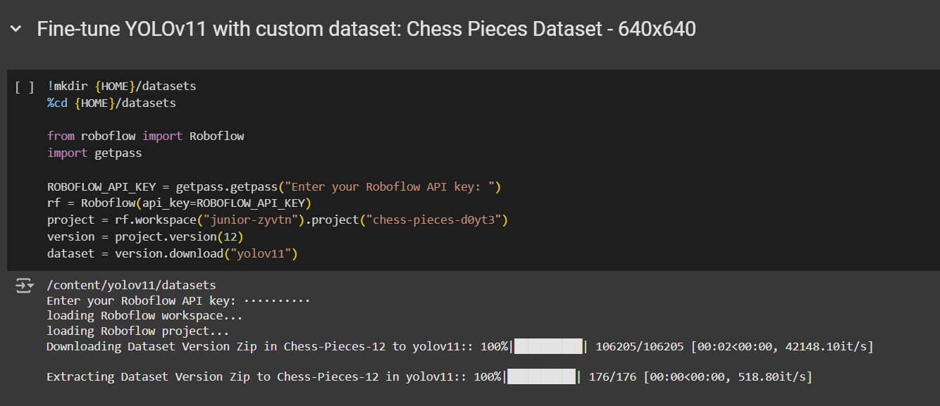

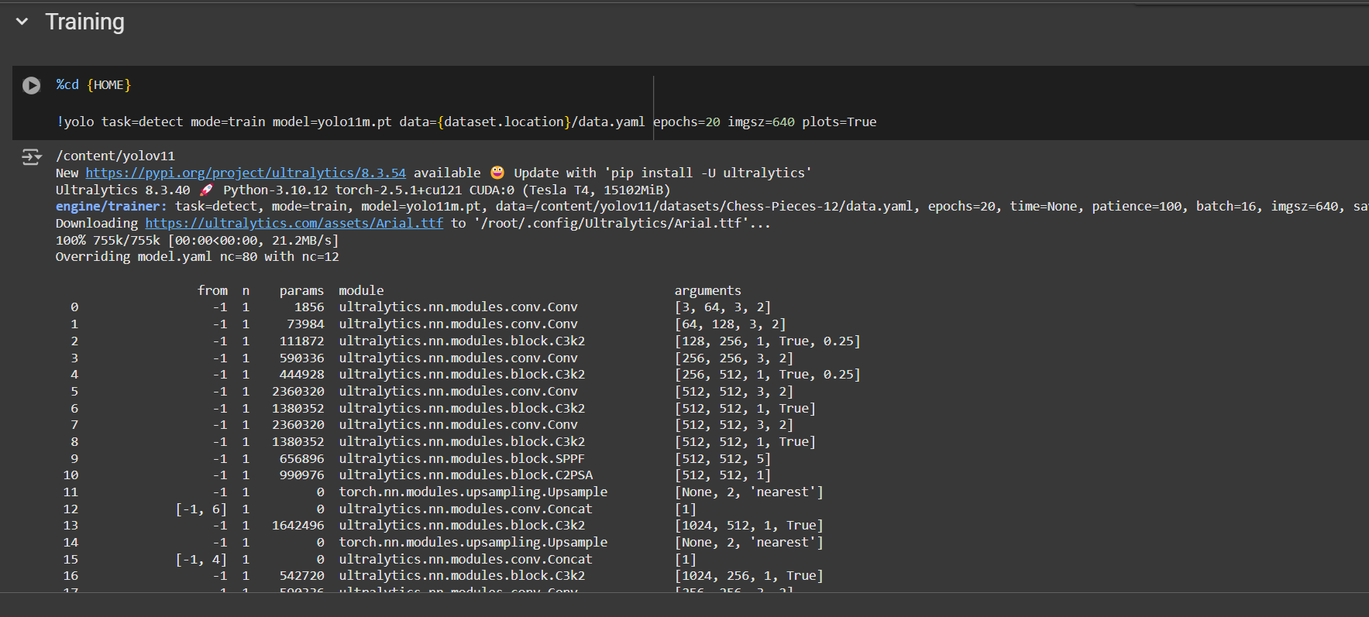

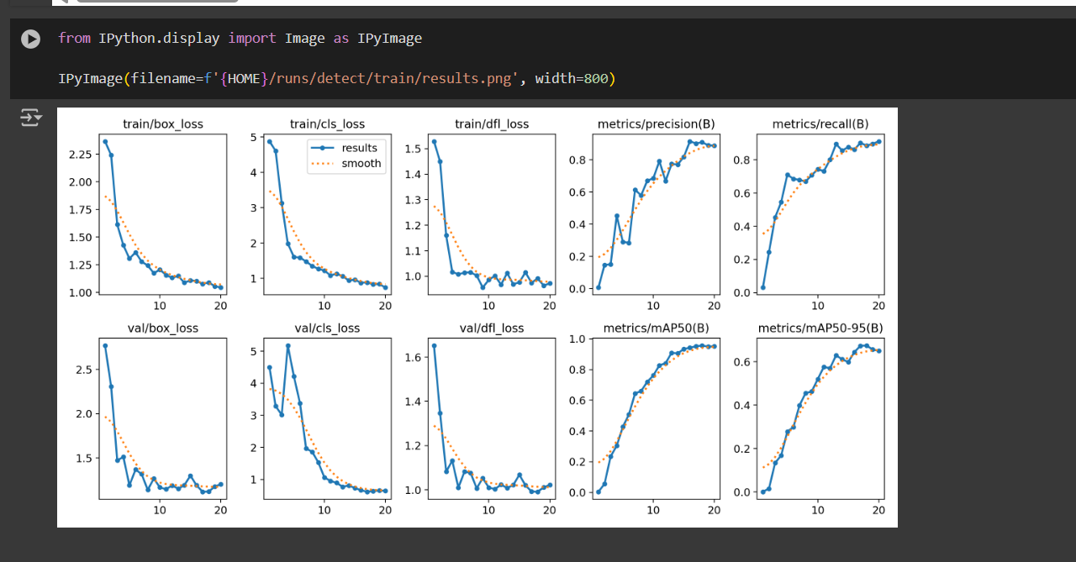

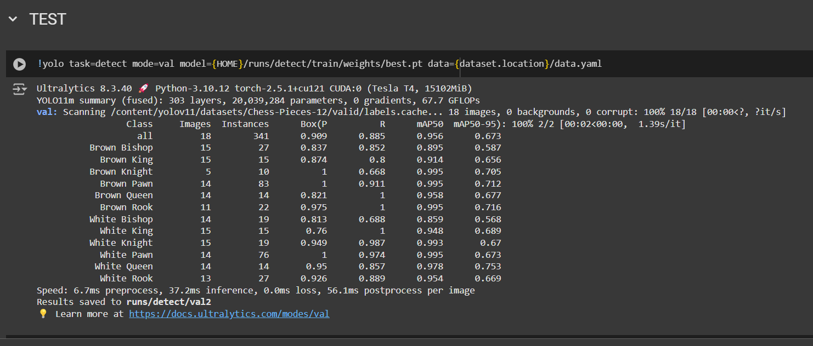

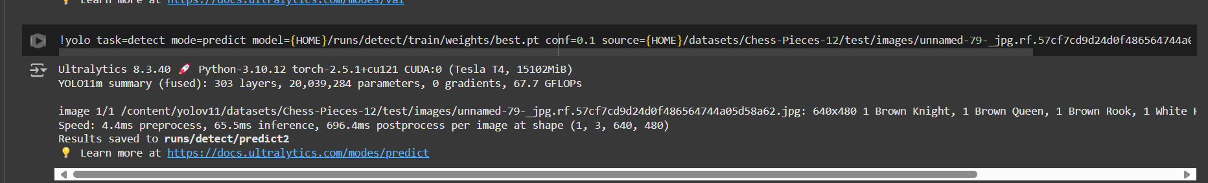

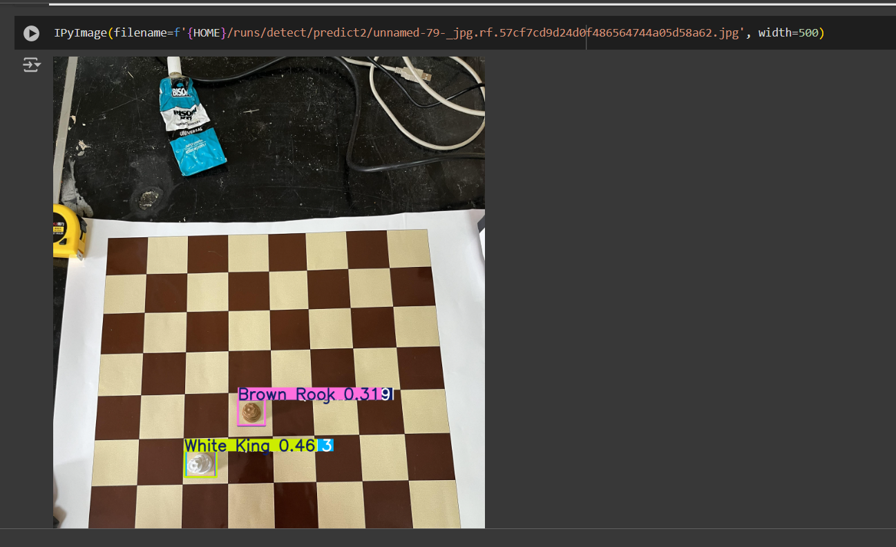

**2. Summary of Function Usage and Explanation**

**1. Install YOLOv11 via Ultralytics**

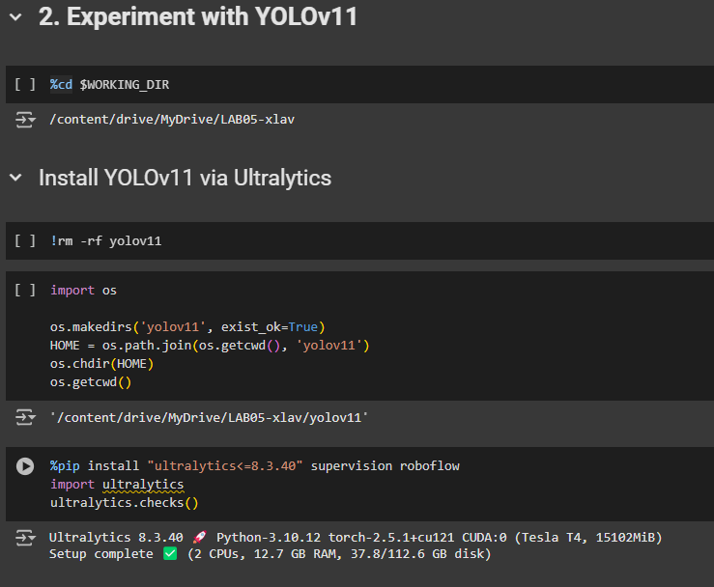

* **%cd $WORKING_DIR**: Changes the working directory to the specified $WORKING_DIR where the YOLOv11 setup will occur.
* **!rm -rf yolov11**: Removes any existing folder named yolov11 to ensure a clean setup.
* **os.makedirs('yolov11', exist_ok=True)**: Creates a directory named yolov11 if it doesn't already exist.
* **HOME = os.path.join(os.getcwd(), 'yolov11')**: Sets the HOME variable to the path of the yolov11 directory.
* **os.chdir(HOME)**: Changes the working directory to the yolov11 folder.
* **%pip install "ultralytics<=8.3.40" supervision roboflow**: Installs the ultralytics package (which contains YOLOv11), along with the supervision and roboflow libraries. These are necessary for YOLOv11 model tasks and interacting with Roboflow for dataset management.
  + ultralytics<=8.3.40: Specifies the version of ultralytics to install (ensures compatibility with YOLOv11).
  + supervision: A library for managing object detection tasks.
  + roboflow: A library to access datasets from Roboflow, which is useful for managing datasets and labeling.
* **import ultralytics**: Imports the YOLOv11 package from the ultralytics library.
* **ultralytics.checks()**: Checks the installation and configuration of the YOLOv11 package to ensure it's correctly set up.

**2. Demo with Command-Line Interface (CLI)**

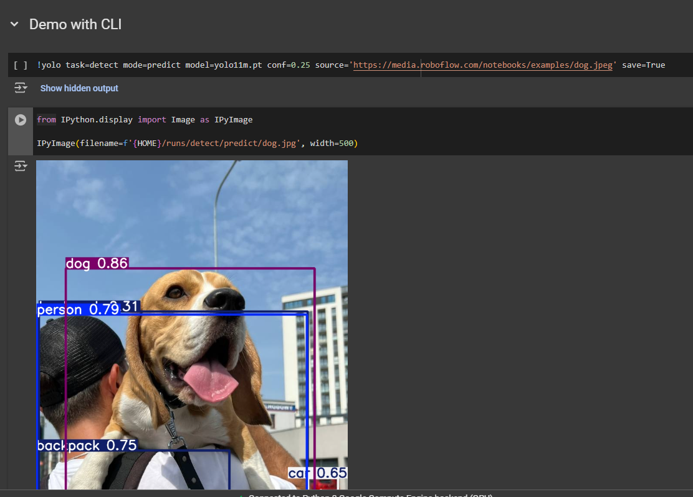

* **!yolo task=detect mode=predict**: Runs the YOLOv11 model in prediction mode for object detection on input images.
  + **task=detect**: Specifies that the task is object detection.
  + **mode=predict**: Indicates that the model will be used to predict objects in images.
  + **model=yolo11m.pt**: Specifies the pre-trained YOLOv11 model file (yolo11m.pt), which is used for predictions.
  + **conf=0.25**: Sets the confidence threshold for detections. Only detections with confidence greater than 0.25 will be considered valid.
  + **source='https://media.roboflow.com/notebooks/examples/dog.jpeg'**: Provides the source image for prediction. This image is from a URL.
  + **save=True**: Saves the resulting image with detected objects to the output directory.
* **from IPython.display import Image as IPyImage**: Imports the Image function from the IPython.display module for displaying images inline within the Jupyter notebook.
* **IPyImage(filename=f'{HOME}/runs/detect/predict/dog.jpg', width=500)**: Displays the resulting image (dog.jpg) from the prediction in the notebook, showing the detected objects.

**3. Fine-Tune YOLOv11 with Custom Dataset (Chess Pieces Dataset - 640x640)**

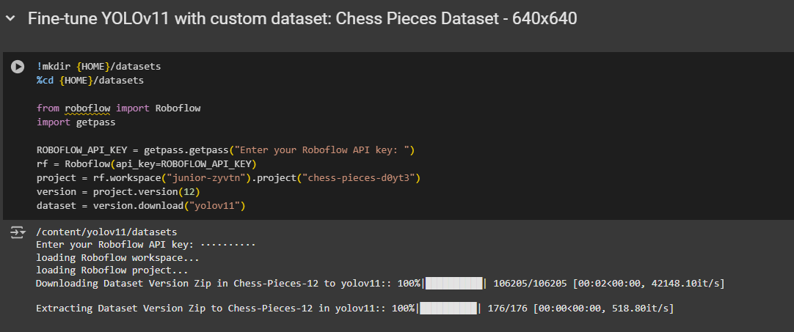

* **!mkdir {HOME}/datasets**: Creates a new directory called datasets within the yolov11 folder to store the dataset.
* **%cd {HOME}/datasets**: Changes the working directory to the newly created datasets folder.

**4. Download Dataset from Roboflow**

* **from roboflow import Roboflow**: Imports the Roboflow class from the roboflow package to interact with the Roboflow API.
* **import getpass**: Imports the getpass module, which securely prompts for the Roboflow API key.
* **ROBOFLOW_API_KEY = getpass.getpass("Enter your Roboflow API key: ")**: Prompts the user to input their Roboflow API key securely.
* **rf = Roboflow(api_key=ROBOFLOW_API_KEY)**: Initializes the Roboflow API client with the provided API key.
* **project = rf.workspace("junior-zyvtn").project("chess-pieces-d0yt3")**: Accesses the specific project (chess-pieces-d0yt3) within the workspace (junior-zyvtn) on Roboflow.
* **version = project.version(12)**: Downloads version 12 of the dataset from the project.
* **dataset = version.download("yolov11")**: Downloads the dataset in a format compatible with YOLOv11.

**5. Train YOLOv11 with Custom Dataset**

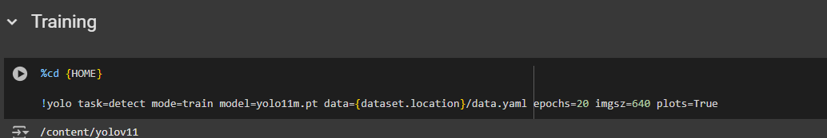

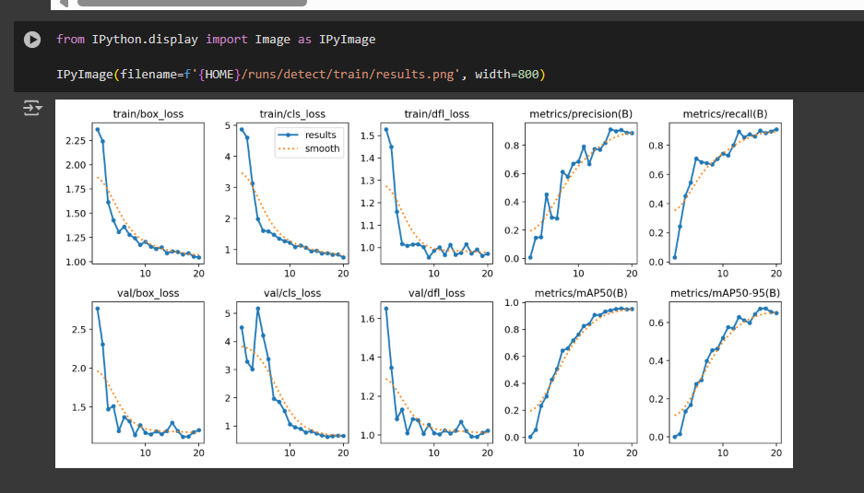

* **%cd {HOME}**: Changes the working directory back to the yolov11 folder.
* **!yolo task=detect mode=train**: Starts the training process for YOLOv11 with the following parameters:
  + **task=detect**: Specifies that the task is object detection.
  + **mode=train**: Runs the model in training mode.
  + **model=yolo11m.pt**: Specifies the pre-trained YOLOv11 model file (yolo11m.pt), which will be fine-tuned with the custom dataset.
  + **data={dataset.location}/data.yaml**: Specifies the path to the data.yaml file, which contains the dataset configuration (e.g., class names and paths).
  + **epochs=20**: Sets the number of epochs for training (20 epochs).
  + **imgsz=640**: Specifies the input image size (640x640).
  + **plots=True**: Enables plotting of training results such as loss curves.
* **IPyImage(filename=f'{HOME}/runs/detect/train/results.png', width=800)**: Displays the training results in the notebook (e.g., loss curve) after training.

**6. Test YOLOv11**

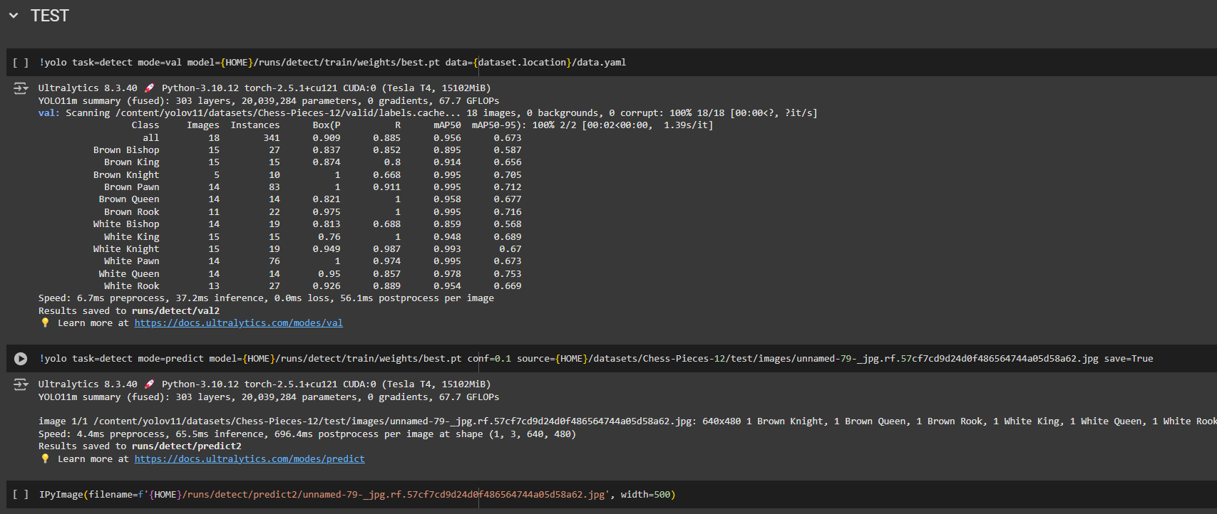

* **!yolo task=detect mode=val**: Runs validation on the trained model:
  + **task=detect**: Object detection task.
  + **mode=val**: Validation mode.
  + **model={HOME}/runs/detect/train/weights/best.pt**: Specifies the path to the best weights after training.
  + **data={dataset.location}/data.yaml**: Specifies the dataset configuration file for validation.
* **!yolo task=detect mode=predict**: Runs prediction on a test image:
  + **task=detect**: Object detection task.
  + **mode=predict**: Prediction mode.
  + **model={HOME}/runs/detect/train/weights/best.pt**: Uses the best weights from training.
  + **conf=0.1**: Sets the confidence threshold for detection.
  + **source={HOME}/datasets/Chess-Pieces-12/test/images/unnamed-79-_jpg.rf.57cf7cd9d24d0f486564744a05d58a62.jpg**: Specifies the source image for prediction.
  + **save=True**: Saves the resulting predicted image.
* **IPyImage(filename=f'{HOME}/runs/detect/predict2/unnamed-79-_jpg.rf.57cf7cd9d24d0f486564744a05d58a62.jpg', width=500)**: Displays the predicted image with detected objects.

**3. Results and evaluations**

**A. Results:**

**a) Demo:**

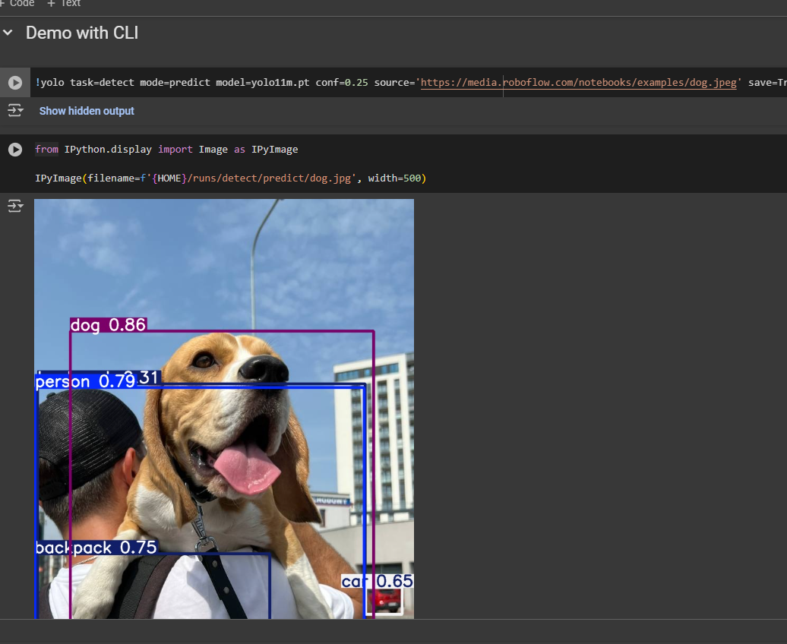

**b) Training (epochs = 20)**

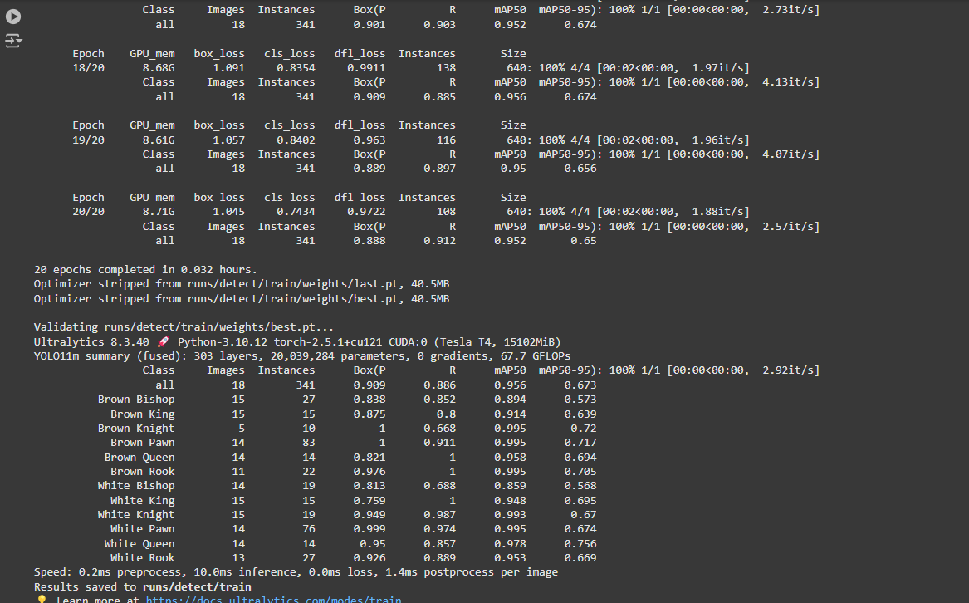

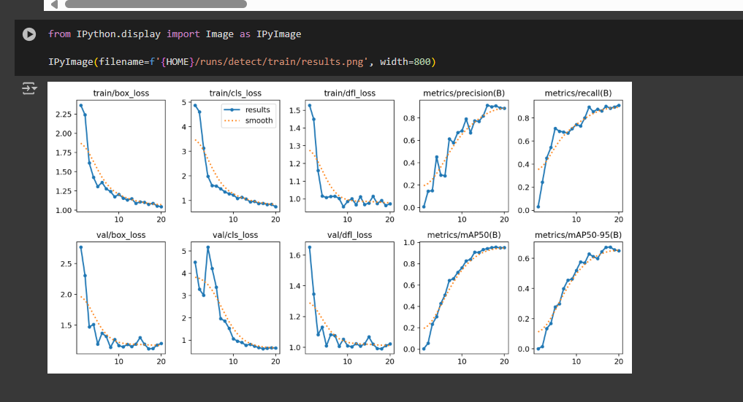

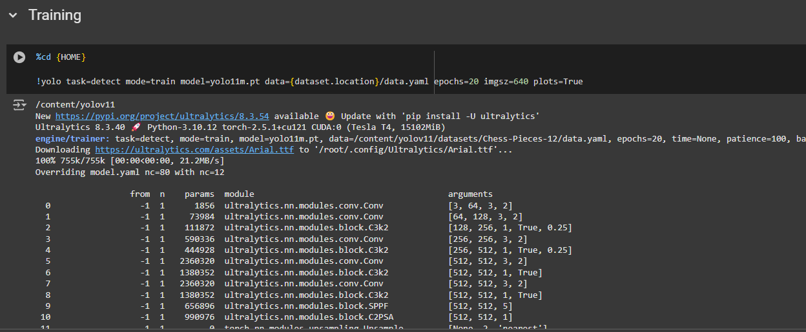

**c) Testing**

I choose 1 random picture in **run/detect/val2 folder** as below to do testing

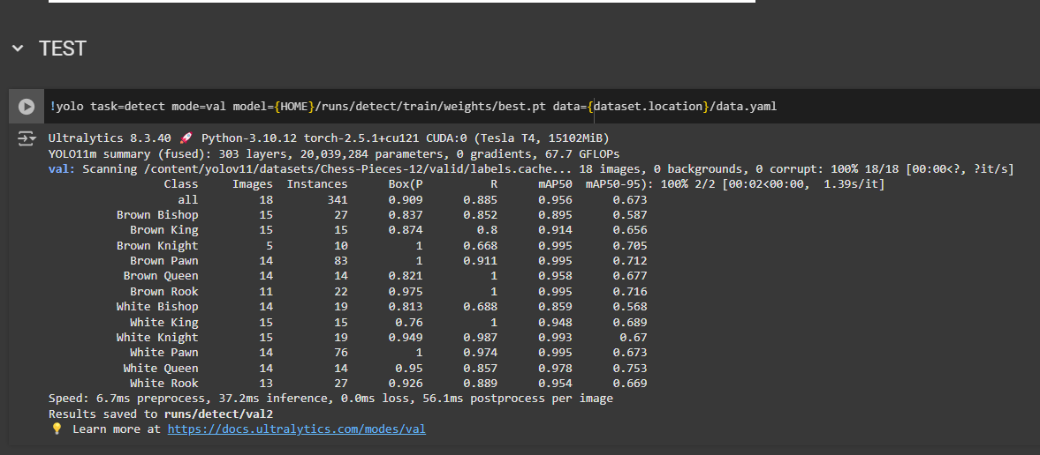

I did testing in the valid folder because in the yolov11 library it is the default mode. Firstly It will run validation on the valid folder image and if this folder doesn’t exists, it will run on the test images folder. If you want to run on the test folder, you can delete the valid folder.

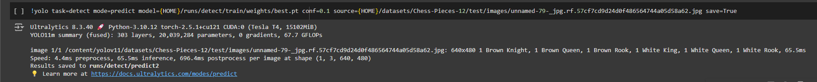

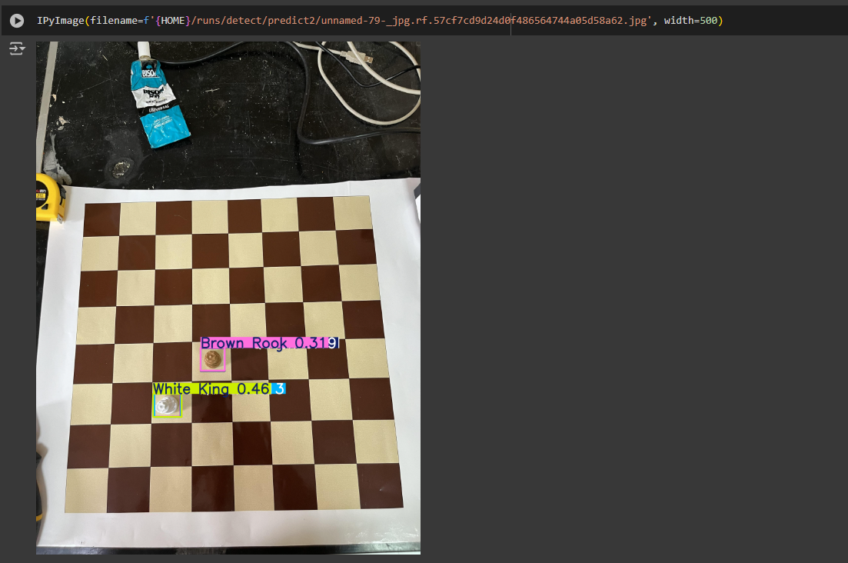

**C. Evaluations**

**YOLOv11 Results**:

Validating runs/detect/train/weights/best.pt...

Ultralytics 8.3.40 🚀 Python-3.10.12 torch-2.5.1+cu121 CUDA:0 (Tesla T4, 15102MiB)

YOLO11m summary (fused): 303 layers, 20,039,284 parameters, 0 gradients, 67.7 GFLOPs

Class Images Instances Box(P R mAP50 mAP50-95): 100% 1/1 [00:00<00:00, 2.92it/s]

all 18 341 0.909 0.886 0.956 0.673

Brown Bishop 15 27 0.838 0.852 0.894 0.573

Brown King 15 15 0.875 0.8 0.914 0.639

Brown Knight 5 10 1 0.668 0.995 0.72

Brown Pawn 14 83 1 0.911 0.995 0.717

Brown Queen 14 14 0.821 1 0.958 0.694

Brown Rook 11 22 0.976 1 0.995 0.705

White Bishop 14 19 0.813 0.688 0.859 0.568

White King 15 15 0.759 1 0.948 0.695

White Knight 15 19 0.949 0.987 0.993 0.67

White Pawn 14 76 0.999 0.974 0.995 0.674

White Queen 14 14 0.95 0.857 0.978 0.756

White Rook 13 27 0.926 0.889 0.953 0.669

Speed: 0.2ms preprocess, 10.0ms inference, 0.0ms loss, 1.4ms postprocess per image

Results saved to runs/detect/train

The results from YOLOv11 show much better performance, with mAP50 at 0.956 and recall values higher than 0.8 for most classes. Additionally, YOLOv11 demonstrated fast processing times (10ms for inference per image), and the results were achieved quickly, making it a more efficient model for this dataset.